
Co-authored by-Raj Prakash, Ujjawal Prabhat

1. Executive Summary
This document outlines the complete implementation plan for adding a Personalized Favorites Feature to OpenMRS. The feature allows healthcare providers to manually bookmark their most frequently used medicines, lab tests, and diagnoses, displaying them prominently at the top of selection dropdowns. This reduces search time from 30-60 seconds to 5-10 seconds per order, significantly improving clinical workflow efficiency. The system is built with a custom database table and extensible architecture, enabling future automatic usage tracking and analytics without requiring data migration.

2. Problem Statement

Current Situation
Healthcare providers using OpenMRS face significant inefficiencies when prescribing medications, ordering lab tests, or recording diagnoses. The current system presents all available options in a single, undifferentiated list, requiring manual scrolling and searching through extensive databases.
3. Key challenges
Challenge | Description
Large Dataset Navigation | Providers must search through comprehensive drug lists containing thousands of items
Repetitive Searches | Most providers regularly use only a small subset of available options, yet must repeatedly search for the same items
No Personalization | The system treats all items equally regardless of individual usage patterns
Cognitive Load | High mental effort required to locate and verify correct items under time pressure
Time Inefficiency | Significant cumulative time lost on repetitive search tasks

Root Cause Analysis
● Comprehensive medical databases contain extensive item lists
● Individual providers typically use only a fraction of available options regularly
● Current user interface displays all items with equal prominence
● No mechanism exists to learn from or adapt to usage patterns

Impact
● Reduced clinical efficiency
● Increased provider frustration
● Potential for selection errors under time pressure
● Cumulative productivity loss across the organization

Overview
Implement a manual favorites system with a robust database architecture that allows healthcare providers to explicitly bookmark their most frequently used items. The system is designed with future extensibility in mind, enabling automatic usage tracking and analytics in later phases.

Solution Components

Manual Favourites Management
- Allow users to manually mark specific items as favourites
- Persist manually added favourites regardless of usage frequency
- Enable removal of manually added favourites at any time
- Combine manual favourites and automatically suggested items in a unified display

Automatic Usage Tracking (Future Enhancement)
- Monitor and record when providers select medicines, lab tests, or other orderable items
- Store usage frequency data per user
- Use collected data to enable intelligent sorting and suggestions
- Ensure tracking is opt-in to respect user privacy

Intelligent Caching
- Cache favourites and usage patterns for faster retrieval
- Reduce repeated database queries for frequently accessed items
- Implement smart cache invalidation to maintain data freshness

Enhanced User Interface
- Display a personalized favourites section at the top of dropdown lists
- Clearly indicate favourited items using visual markers
- Maintain access to the complete item list below the favourites section
- Support type-ahead search across favourites and full list

Multi-Entity Support
- Apply the same favourites pattern across medicines, lab tests, and other order types
- Ensure context-aware display based on the current order screen
- Design the system to be easily extensible for additional entities

SOLUTION ADVANTAGES

Aspect | Benefit
User Control | Provides users explicitly chose their favourites
Low Complexity | Simple star/unstar interaction familiar from common applications
High Performance | Indexed database queries enable fast and reliable retrieval
True Personalization | Favorites are maintained per user, not shared globally
Extensible Architecture | Dedicated tables support future analytics and reporting
Data Integrity | Foreign key constraints ensure referential consistency
Future-Ready Design | Supports analytics, team sharing, and smart recommendations
Privacy Respecting | No tracking in Phase 1; Phase 2 requires explicit consent

User Experience Transformation

Before Implementation
- Provider opens the medication selection screen
- A complete list of medications is displayed (often 1,000+ items)
- Provider manually searches or scrolls to locate the required medication
- The correct option is identified and selected
- This process is repeated for every prescription, for every patient, every day
After Implementation (Phase 1 – Manual Favorites)
- Provider opens the medication selection screen
- A favorites section is displayed at the top (typically 5–15 commonly used items)
- Frequently prescribed medications are immediately visible
- Common selections are made with a single click
- New items can be added to favorites using the star icon as prescribing patterns evolve
- The full medication list remains accessible below the favorites section
- Type-ahead search filters both favorites and the complete list instantly

After Implementation (Phase 2 – Future Enhancement)
- Provider opens the medication selection screen
- Manually pinned favorites are displayed at the top
- Frequently used items are automatically identified and shown
- Additional suggestions are generated based on usage patterns
- The system continuously learns and adapts to user behavior
- Seasonal trends (e.g., flu-related medications) are reflected automatically
- The experience improves over time without additional user effort

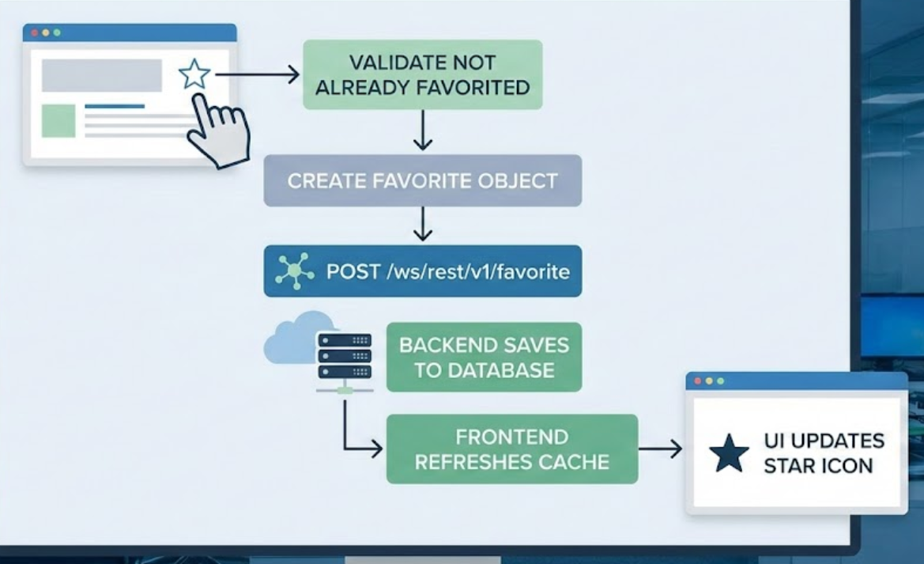
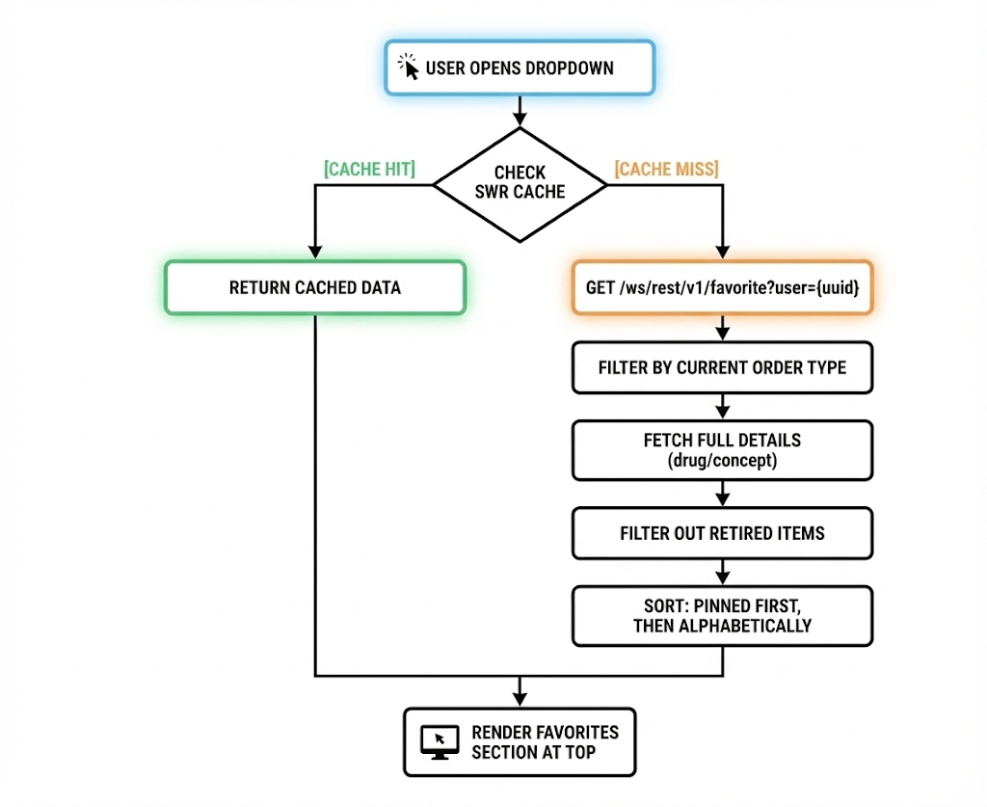
Key Design Decisions

User-Centric Storage
Decision: Store favorites per user_id, not provider_id.
Rationale:
- Favorites are UI preferences tied to the logged-in user.
- Ordering on behalf of another provider should not affect favorites.
- Aligns with common patterns (e.g., browser bookmarks).

Drug vs Concept Distinction
Decision: Use orderable_type with values 'drug' or 'concept'.
Rationale:
- Drugs are specific formulations; concepts cover labs, procedures, referrals.
- Required to route to correct REST endpoints.
Mapping:
- Drug orders → /ws/rest/v1/drug
- Lab tests / Procedures / Referrals → /ws/rest/v1/concept

Order Type References
Decision: Store order_type_uuid instead of hardcoded enums.
Rationale:
- Supports custom order types without code changes.
- Configuration-driven and extensible.
Examples:
- Drug Order: 131168f4-15f5-102d-96e4-000c29c2a5d7
- Test Order: 52a447d3-a64a-11e3-9aeb-50e549534c5e

Single Record Design
Decision: One record per (user_id, orderable_uuid).
Fields:
- is_pinned — manual favorite
- usage_count — frequency (Phase 2)
- last_used — last usage time (Phase 2)
Scenarios:
- Manual only, automatic only, or both combined.
Benefit: No duplicates, simple logic.

Voided / Retired Data Handling
Decision: Preserve records; filter retired items at display time.
Implementation:
- Retired items remain stored for audit.
- Hidden from UI until un-retired.
Optional: Notify user when favorites are unavailable.
Caching Strategy
Frontend:
- SWR (useSWRImmutable)
- Key: /ws/rest/v1/favorite?user={userId}
- Manual invalidation via mutate()
Backend:
- Hibernate second-level cache.
Rationale: Favorites change only on user action.

5. Database Design

Table Structure
Table Name: favorite_order

Phase 1 Schema (Manual Favorites Only)

Column | Type | Description
favorite_order_id | INT, PK, AUTO_INCREMENT | Unique identifier
uuid | CHAR(38), UNIQUE | UUID for REST APIs
user_id | INT, NOT NULL | Owner of the favorite (user-centric)
orderable_uuid | CHAR(38), NOT NULL | UUID of drug or concept
orderable_type | VARCHAR(20), NOT NULL | drug or concept
order_type_uuid | CHAR(38), NOT NULL | Reference to order_type (extensible)
creator | INT, NOT NULL | Record creator
date_created | DATETIME, NOT NULL | Creation timestamp
voided | BOOLEAN, DEFAULT FALSE | Soft delete flag
voided_by | INT | User who voided
date_voided | DATETIME | Void timestamp
void_reason | VARCHAR(255) | Void reason

Phase 2 Enhancements (Usage Tracking)
- usage_count INT DEFAULT 0 — usage frequency
- last_used DATETIME — last usage timestamp
- is_pinned BOOLEAN DEFAULT TRUE — manual vs auto-promoted

Constraints
- Primary Key: favorite_order_id
- Unique: (user_id, orderable_uuid) — one favorite per user per item
- Check: orderable_type IN ('drug', 'concept')
- Foreign Keys:
  - user_id → users.user_id
  - creator → users.user_id
  - order_type_uuid → order_type.uuid

Indexes
Phase 1
- idx_user_favorites (user_id, voided) — active favorites per user
- idx_orderable (orderable_uuid) — favorite lookup
Phase 2
- idx_usage (user_id, voided, usage_count DESC) — usage-based sorting
Design Rationale
Included
- Standard OpenMRS audit fields
- user_id (not provider_id) for UI-level personalization
- orderable_type to distinguish drugs vs concepts
- order_type_uuid for extensibility across order types
Deferred to Phase 2
- Usage tracking fields (usage_count, last_used)
- is_pinned flag (required once auto-promotion is introduced)
Why This Design
- Simple Phase 1 focused on manual favorites
- Aligns with OpenMRS schema conventions
- Phase 2 is additive (no breaking changes)
- No data migration required

Migration Strategy
- Phase 1: Liquibase changeset for base table
- Validate in development environment
- Phase 2: Add usage-related columns via separate changeset
- Fully version-controlled and reversible
