OT Scheduling Documentation:

Functional Overview 2
Creating a surgical block 4
Adding a surgery to the block 5
Rearranging surgeries in a block 7
Calendar view of the surgeries by the day 7
List view of the surgeries by the day and the week 9
Mockup: 11
Ability to print list view 11
Filter Functionality for both list and calendar view 12
Ability to add “actual time” to an surgery to be able to compare est time vs actual time 13
Edit, Cancel or Postpone Blocks 14
Edit, Cancel or Postpone Surgery 16
OT Roles and Privileges: 18
Surgical Queues - “To be scheduled” & “scheduled” 19
Surgical Appointment Display Control in Patient Summary Dashboard 19
High Level DB Schema 21
Frequently asked questions 22

Functional Overview

Hospital Operating Theatre (OT) scheduling involves an arrangement of several operating rooms to the medical surgeons in a period of time. In the health service sector the scheduling of Operating Theatre plays an important role towards achieving their goals. Their main goal is to meet the patient’s satisfaction by minimizing their total waiting time before undergoing major or minor operations. Poor scheduling of Operating Theatre may cause longer waiting time and can also worsen the patient’s disease. In this case, an effective schedule has to be created and maintained by the hospital. Another objective is to maximize the surgical activity in the hospital of Amman given the nature of the hospital and the mission on which it is running.

There is an increasing need of optimizing the availability of the operating theatre by minimizing the under-allocation of each operation room.

Scheduling of Hospital Operating Theatre can be divided into several types of strategies which are
- open scheduling,
- block scheduling and
- modified block scheduling

Open scheduling allows surgical cases to be assigned to an operating room available at the convenience of the surgeons.

Block scheduling, allows assignment of specific surgeons or groups of surgeons to a set of time blocks, normally for some weeks or months, into which they can arrange their surgical cases. In the pure form, the surgeon or group "owns" their time blocks. None of those time blocks can be released.

Modified block scheduling is modified into two ways to increase its flexibility. Either some time is blocked based on the surgeries to be performed and some is left open, or unused block time is released at an agreed-upon time before surgery and allotted to another Surgeon.

Implementation of different types of operating theatre scheduling is based on the complexities of the real situation in the hospitals.

Based on the needs of the Hospital of Amman, we agreed that “Modified Block Scheduling” best suits the needs of Amman.

Block Scheduling module helps maximize your operational efficiencies and profits by providing a flexible tool to manage block scheduling. You can reserve blocks of resource time for particular providers, provider groups, procedures, service types and patient types.

Features Bahmni OT Block Scheduling module includes:
- Resource reservation for specific surgical appointments, based upon multiple parameters
- Timed release of underutilized blocks
- Manual release and/or removal of blocks by authorized users
- Block conflict warnings
- Flexible definitions of blocks and free scheduling of appointments within the block
- Utilization metrics, based upon historical data, Estimated & Actual time recording
- Print Weekly OT Schedules
- Ease of OT Schedule creation pulling procedure information from observations
- Guide OT admins to create schedules for “Surgery Ready” patients
- Authorized users can create, edit, release or remove various types of blocks.

Enhancements & Not in Scope :
- Actual Time updates to the OT Schedules on calendars
- Automatic movement of Surgical appointments or blocks across operation theatres.

Creating a surgical block
For a user to be able to create a new block, user must navigate to Operation Theatre/OT Scheduling/New Surgical block
To be able to create a surgical appointment a user must first create a block. A block is created against a Surgeon. The mandatory fields while creating a block are:
- Surgeon
- Location
- Start Date-Time
- Start End-Time
Surgeons is a list of surgeon names that comes for the OT config
Locations is a list of locations in openMRS that are tagged with operation theatre
Start Date-Time and Start End-Time are fields that you have to enter to be able to block that time for the surgeon against that location.
Validations:
- A surgeon cannot have overlapping blocks across OTs
- OT can have multiple blocks but only one block is allowed at a point of time in an OT

TIME | OT1 | OT2 | OT3
8am | Surgeon 1 | Surgeon 4 | Surgeon 5
9am | Surgeon 2 |  | Surgeon 1
10am | Surgeon 3

In the above example, Surgeon 1 cannot be blocked for OT2 & OT3 from 8am to 9am. Since he/she is blocked for OT1 during that time, but surgeon 1 was blocked for OT3 from 9am to 11am.
Mock up:

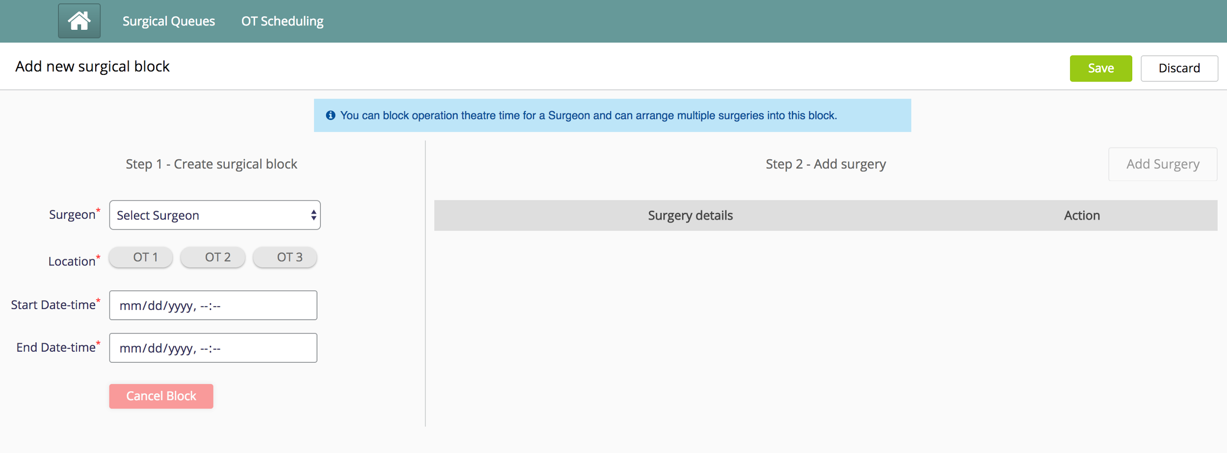

Adding a surgery to the block
After creating a surgical block a user can add multiple surgeries to the block. User can create surgeries for patients. Below are fields that a user can provide to create an surgery
Field | Description | Mandatory | Default
Patient | Auto complete field searchable by patient ID or Name | Yes | None
Procedures | The list of Procedures to be performed on the patient | No | When a patient is selected: If surgeon pre-op or follow up form is filled, this information is pulled from the latest form  If no form has been filled then the field will be blank
Est Time | The Estimated time of the surgery | No | When a patient is selected: If surgeon pre-op or follow up form is filled, this information is pulled from the latest form  If no form has been filled then the field will be blank
Cleaning time | The Cleaning time needed post surgery | No | 15 mins
Other Surgeon | Drop down list of configured surgeons | No | None
Surgical Assistant | Free text field | No | None
Anaesthetist | Free text field | No | None
Scrub Nurse | Free text field | No | None
Circulating Nurse | Free text field | No | None
Notes | Free text field | No | None

After adding the desired surgeries user will have to click on save to save the added surgeries in a block. Until save is clicked, the data added will be light in color (represents unsaved data)
There is a timer that shows “remaining block duration” that will update every time you add a surgery

Validations:
The Total time(Est time + Cleaning time) of the surgeries cannot exceed the total blocked time.
A patient cannot have multiple surgeries in different overlapping blocks.
Example, Block 1 (10am to 7pm, 1st Jul) Block 2(10am to 5pm, 1st Jul). Patient x can have an surgery in only one of the blocks

Mock up:
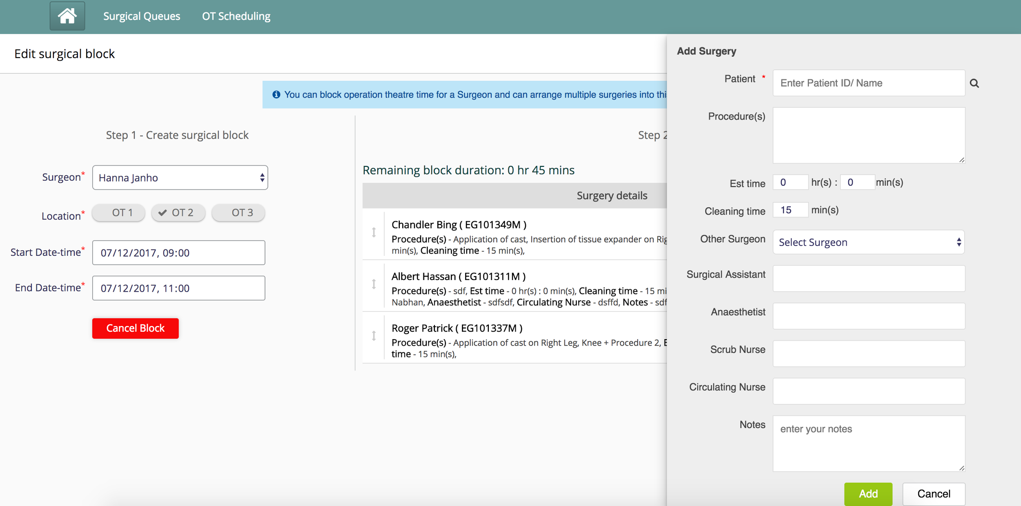

Rearranging surgeries in a block
When a user adds more than one surgery in a block, the user can rearrange the surgeries in a block by dragging and dropping the surgeries. After rearranging the surgery user needs to click on save to save the changes.

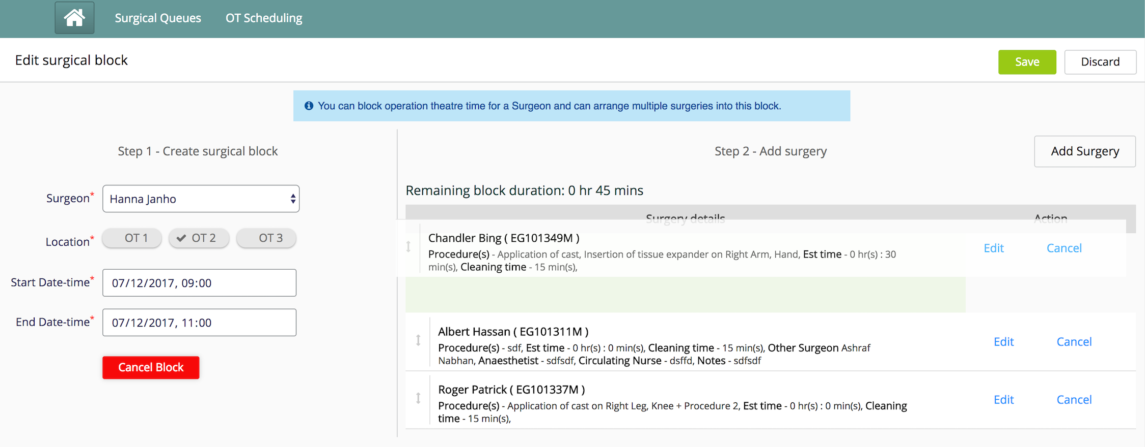
Validations:
The surgery can only be dropped in the surgery section.
**There is no indication currently to show unsaved rearrangement. User has to click on save to save changes**

Calendar view of the surgeries by the day
- Calendar view is the default view a user sees when clicked on “OT Scheduling”. The calendar view shows surgical blocks with surgeries. The calendar view only shows scheduled and completed surgeries. Cancelled and postponed blocks and surgeries are not available on calendar view.
- Each surgery in the calendar view has the following information displayed:
  - Patient Name & Patient ID
  - Estimated time of the surgery
  - Procedures
  - Anaesthetist
  - Notes
  - Actual time, if any
- In Calendar view, users can navigate by days (forward and backward). When user clicks on today, current day view is shown. There is a date displayed to indicate the day the user is viewing.
- Current time is highlighted by a red line on the calendar
- There is an arrow against each surgery to expand the surgery for more information.The Surgeon name appears in the end of the block.
- A user can “add actual time”, “edit” and “cancel” a surgery from calendar view. A completed surgery has a tick mark against it in the calendar view. We will learn about these features in detail in their respective sections.

Mock up:
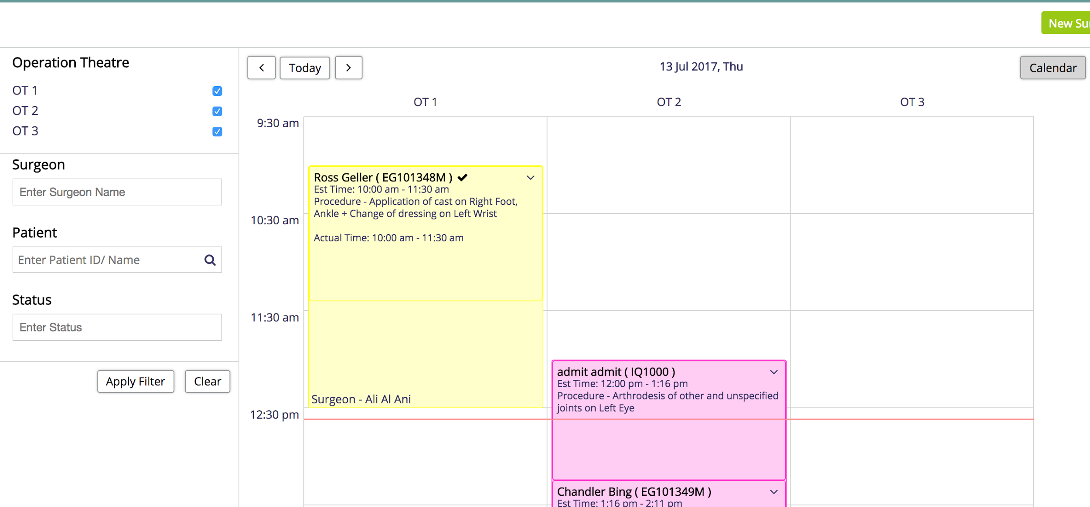

Validations and constraints:
- The time on Y axis of the calendar is configurable but a user can schedule blocks beyond the configured time. When that happens the blocks will overflow from the calendar indicating the overflow. In order to see the details of the surgeries or the blocks, user will have to change the configuration.
Example:
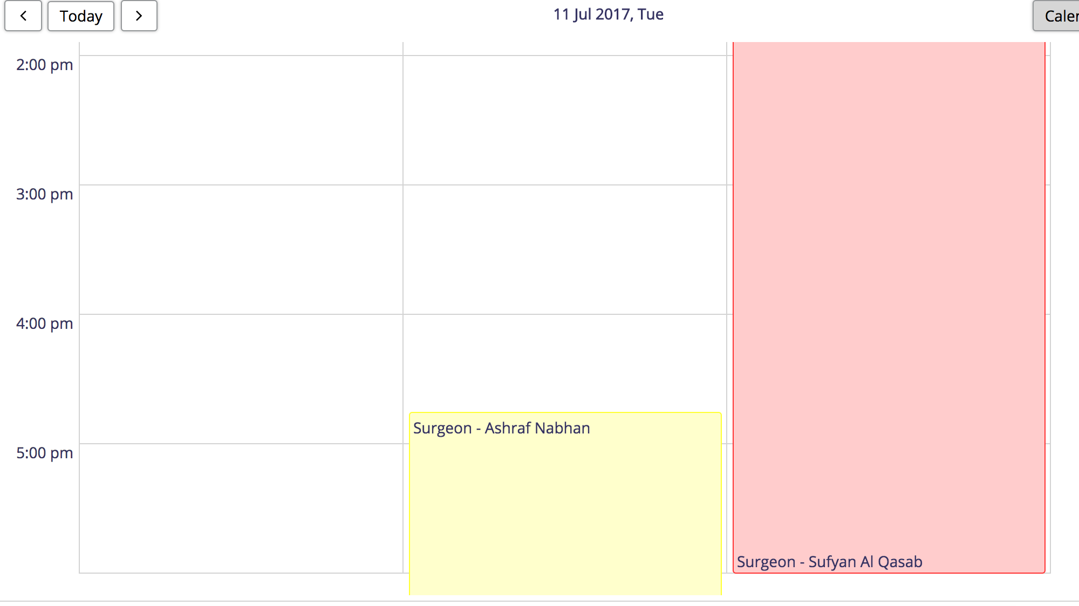

- Each Surgeon is associated with a color and the colors are configurable. The steps to configure those colors are provided here.

List view of the surgeries by the day and the week
- There is an option to choose list view on the screen. The default list view will be the day on the calendar view the user is navigating from. When week view is selected after navigating to list view, it displays the current week surgeries (Sunday to Saturday).
- The List view shows all surgeries by default (Scheduled,Completed,Cancelled & Postponed). However, if a filter was applied on the calendar view, the list view adapts the filter too when navigated.
- The list view also provides the user the ability to navigate days/weeks forward and backward. When clicked on Today/This week the user is taken to the current day or the current week, depending on the view the user is on.
- In a week view, current day's’ surgeries are highlighted with a gray background
- A user can “add actual time”, “edit” and “cancel” a surgery from calendar view. We will learn about these features in detail in their respective sections.
- The list view,both day and week, surgeries will comprise of the following information:

Field | Description
Date | Date of Surgery
Identifier | Patient Identifier
Patient Name | Name of the patient
Start time | Start time of the surgery calculated by estimated time and placement of surgery in block
Est Time | Estimated duration of the surgery + cleaning time
Actual Time | Actual time, if added any
OT# | The OT the surgery was scheduled in
Procedure(s) | List of procedures in the surgery
Notes | Notes captured as a part of surgery
Surgeon | Surgeon name the the surgery was scheduled with
Other Surgeon | Other surgeon selected from the drop down while adding surgery
Surgical Assistant | Surgical assistant entered during the addition of surgery
Anaesthetist | Anaesthetists entered during the addition of surgery
Scrub Nurse | Scrub Nurse entered during the addition of surgery
Circulating Nurse | Circulating Nurse entered during the addition of surgery
Status | The current status of the surgery
Status Change Notes | If the status has been changed, the notes added will appear here

Mockup:
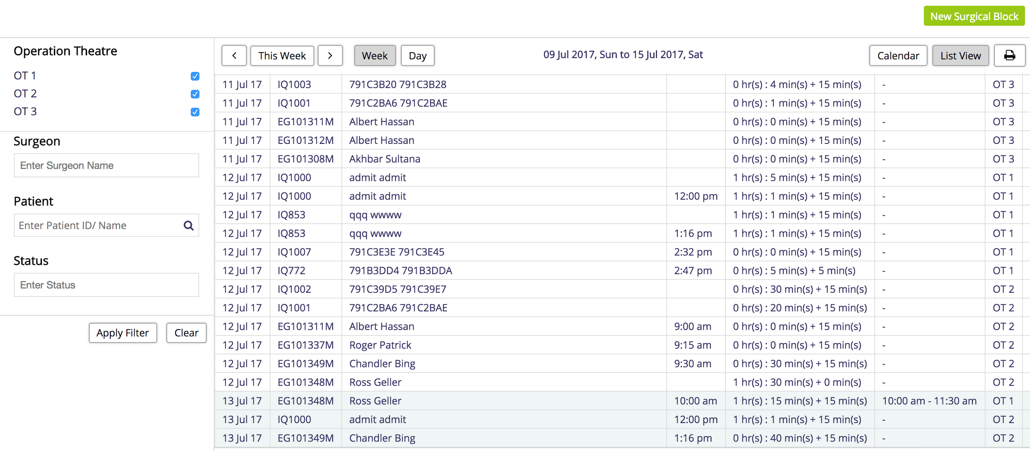

Ability to print list view
Users will be able to print the list view by clicking on the print button beside the list view button. The print version will only print specific columns of the table. The columns to print are configurable and they can be found in the configuration document here.
Currently, the configured columns are:
Date, Identifier, Patient Name, Start time, Est time, Procedure(s), Surgeon, Status.

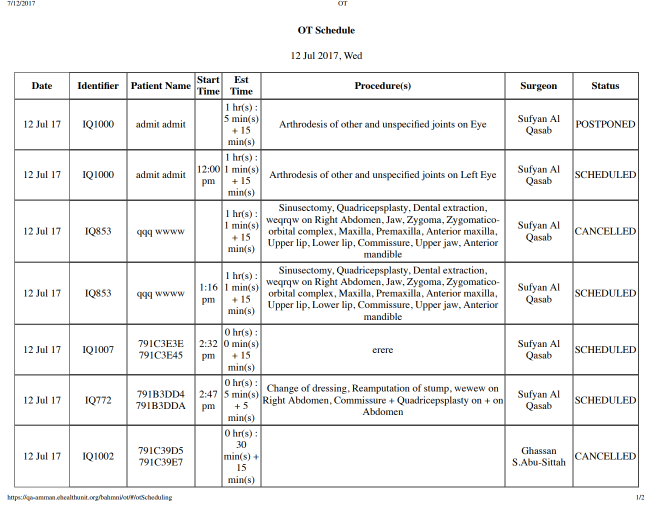

Ability to move surgeries from one block to another
In Calendar view/List View there is a button called “Move”. On click of move, there will be a pop up where user needs to entered the desired date, surgeon name and available block time to move the selected patient.
The destination block drop down will only show those blocks that can accommodate this surgery.
If there are blocks free, “No free time slots available for the selected date” error is shown
In this case, the user is expected to create a block and then try to move the surgery.

**Movement of surgeries across blocks is not tracked**

Mock ups:
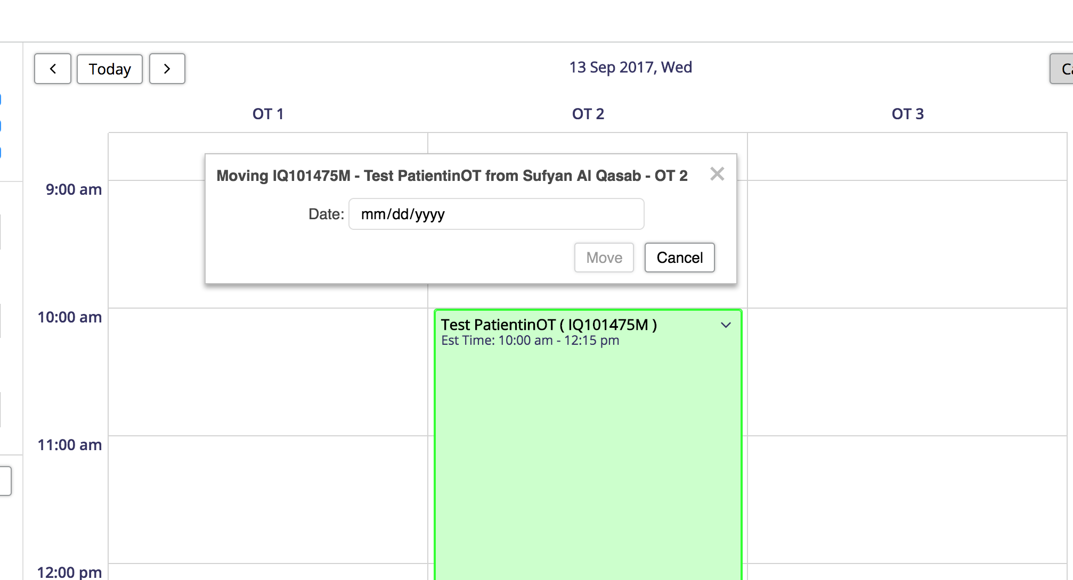

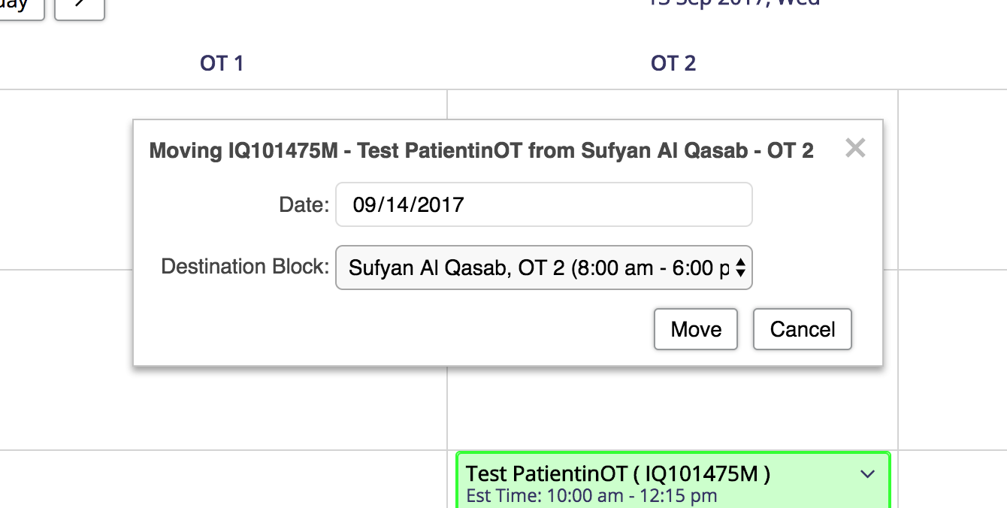

Filter Functionality for both list and calendar view
There is a filter on the left side of the page on OT. it is available for both calendar view and list view. A user will be able to filter based on the following:

OT | User can select multiple OTs
Surgeon | User can filter on multiple surgeons
Patient | User can select only one patient
Status | User can select multiple statuses

After adding the filter a user has to click on apply filter
“Clear” button clears the filter and switches to default view.

Validations and constraints:
The filters for each option are interrelated, For example: If a user selects a surgeon and a patient the combination of the surgeon and patient is filtered.

Mockups:

List view filter:
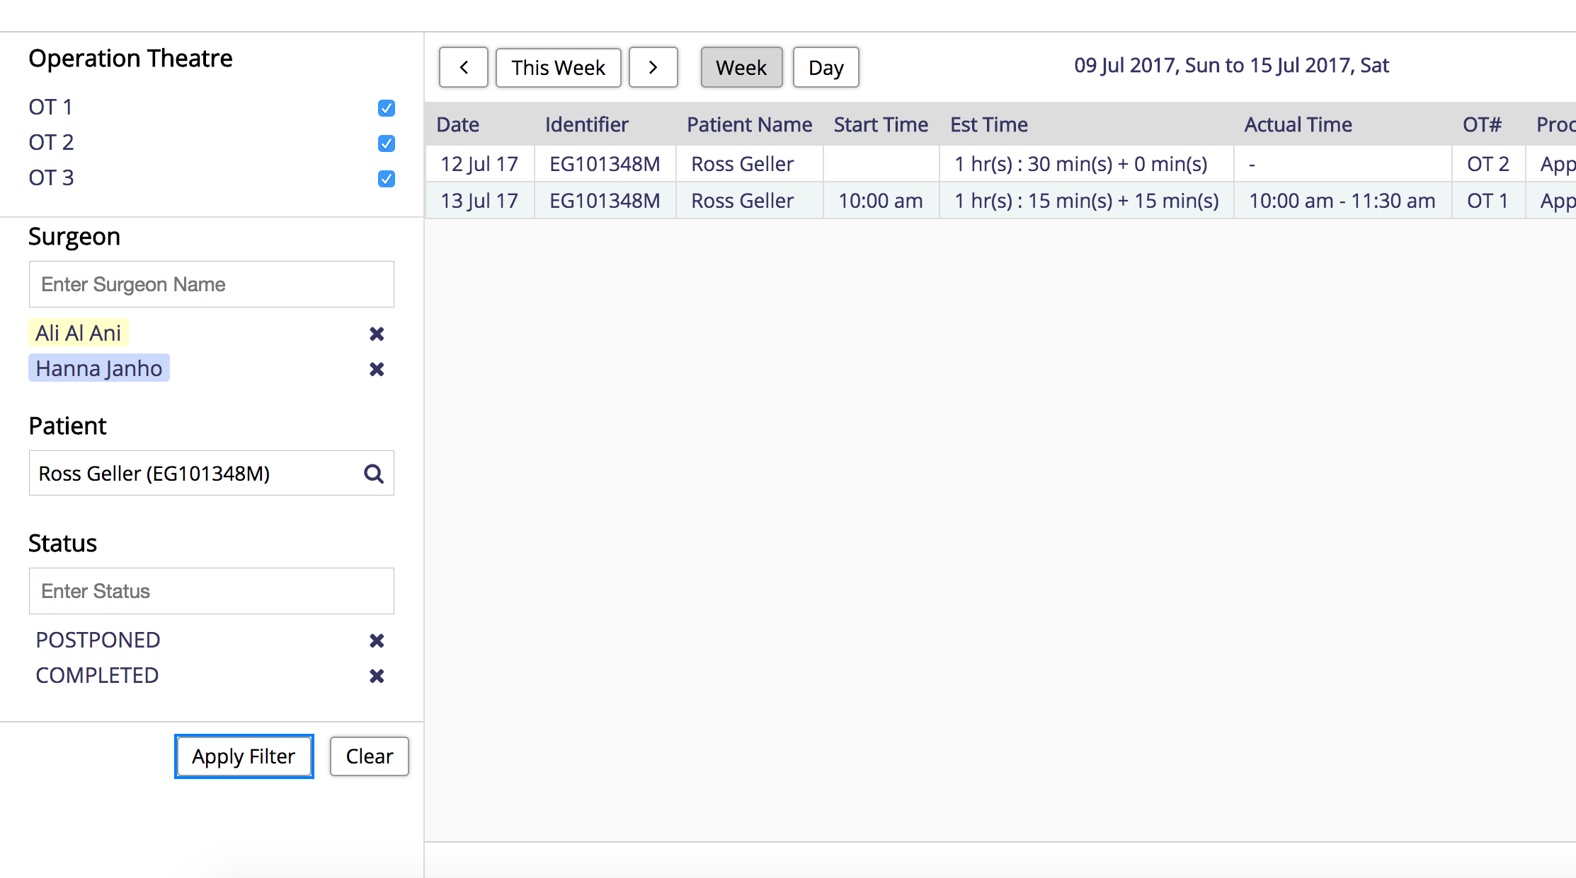

Calendar view filter:
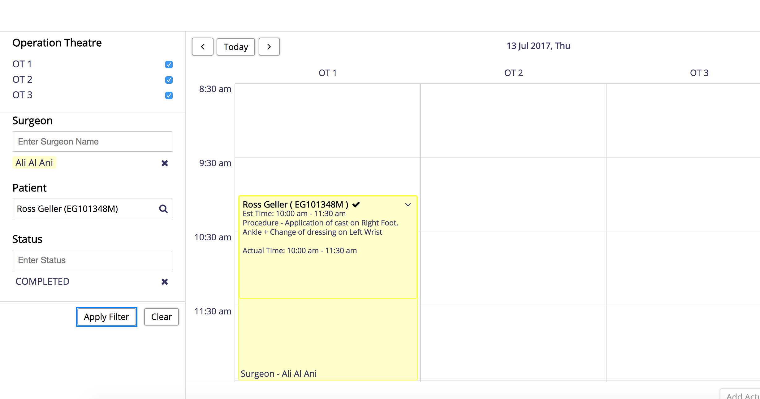

Ability to add “actual time” to an surgery to be able to compare est time vs actual time
There is a provision for the users to be able to add “actual time” against a surgery on the bottom left
Actual time represents that the surgery has been completed and it may vary from estimated time given during the addition of the surgery.

A user can add actual time from list and calendar view. To be able to add an actual time user must select a surgery.
By default the actual start and end time with populate based on the placement of surgery in a block and its estimated time.
Example: Block A has been blocked from 10am to 5pm
Surgery for Patient | Estimated time + Cleaning time | Default actual time
Patient X | 2 hrs 15 mins + 15 mins | 10am to 12:30 pm
Patient Y | 1 hr 30 mins + 15 mins | 12:30pm to 2:15 pm
Patient Z | 30 mins + 15 mins | 2:15pm to 3:00pm
**The actual time includes the cleaning time as well**

Validations and constraints:
- Once an actual time is entered the surgery status changes to “completed” and a tick mark appears on the surgery in the calendar view
- A user can add actual times to only scheduled and completed surgeries
- A user can remove actual time for a surgery and the surgery goes back to “Scheduled” status
- A user cannot add actual time to postponed or cancelled surgeries
- A user can enter actual time multiple times but only the latest entered value is considered.

Mock ups:
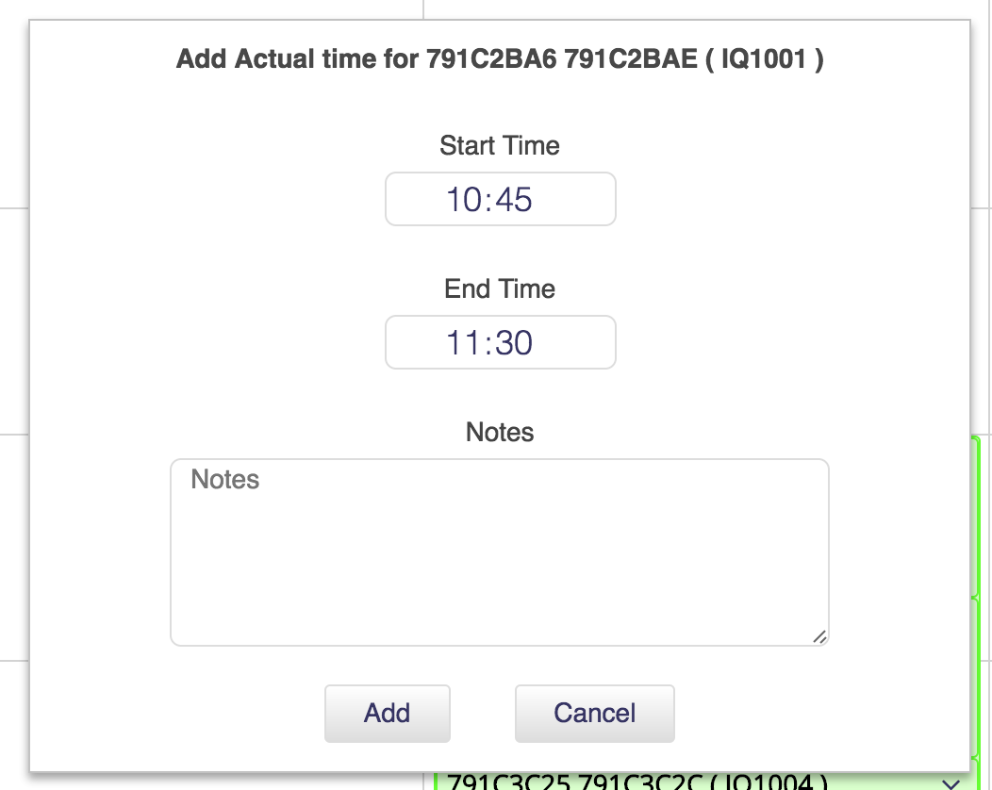

Edit, Cancel or Postpone Blocks
A user can perform the below actions on a block
- Edit Block:
  - A user can edit blocks from calendar view only
  - To be able to add surgeries in a block that has already been created a user must edit the block
  - A user needs to select a block in the calendar view and the edit button on the left bottom will enable
  - Upon clicking on edit, user will be taken to edit surgical block page where users can see surgeries associated with the block

**All the fields in the block are editable**

- Cancel Block:
  - A user can cancel a block from calendar view
  - A user can also cancel a block from “edit surgical block” view
  - A user needs to select a block in the calendar view and the cancel button on the left bottom will enable
  - When cancel is selected, there is a pop up that asks if a user wants to cancel the block or postpone it.
  - User has to click on cancel, select “Cancel block” and enter a reason in order to cancel the block
  - If a block has a “completed” surgery, a user will not be able to cancel the block
  - When a block is cancelled, all its surgeries are also cancelled
  - Once a block is cancelled, the block will not appear in the calendar view

- Postpone Block:
  - A user can postpone a block from calendar view
  - A user can also postpone a block from “edit surgical block” view
  - A user needs to select a block in the calendar view and the cancel button on the left bottom will enable
  - User has to click on cancel, select “Postpone block” and enter a reason in order to postpone the block
  - If a block has a “completed” surgery, a user will not be able to postpone the block
  - Once a block is postponed, all its surgeries are also postponed
  - Once a block is postponed, the block will not appear in the calendar view

Note: In order to reschedule the postponed surgeries of the block, a user will have to create a new surgery for the patient.

Mock ups:
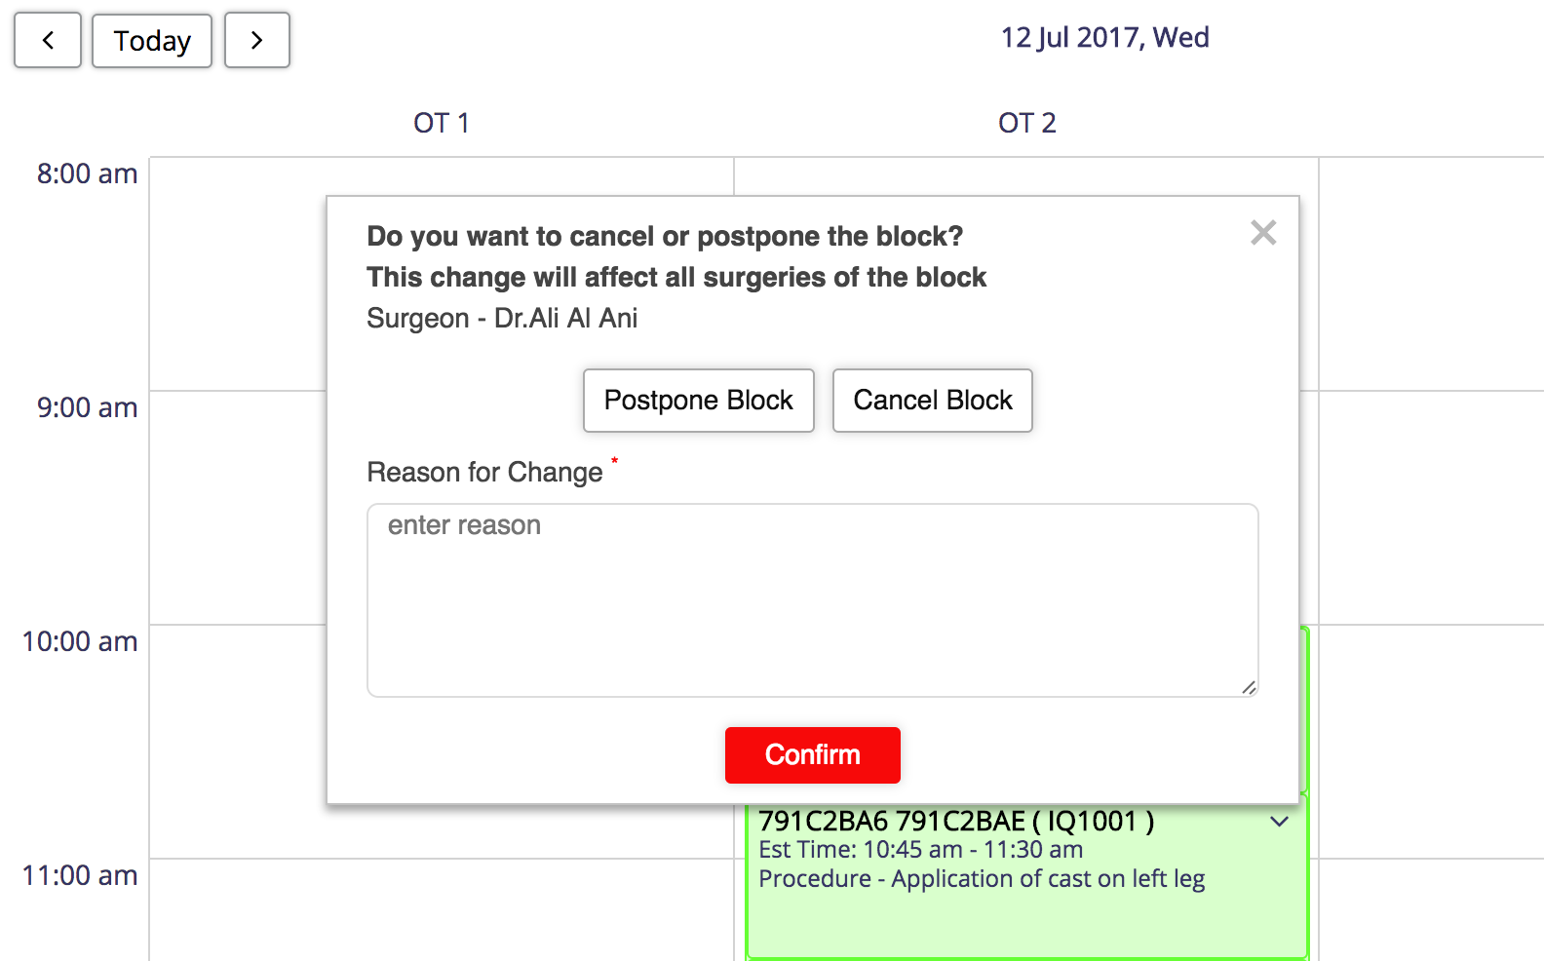

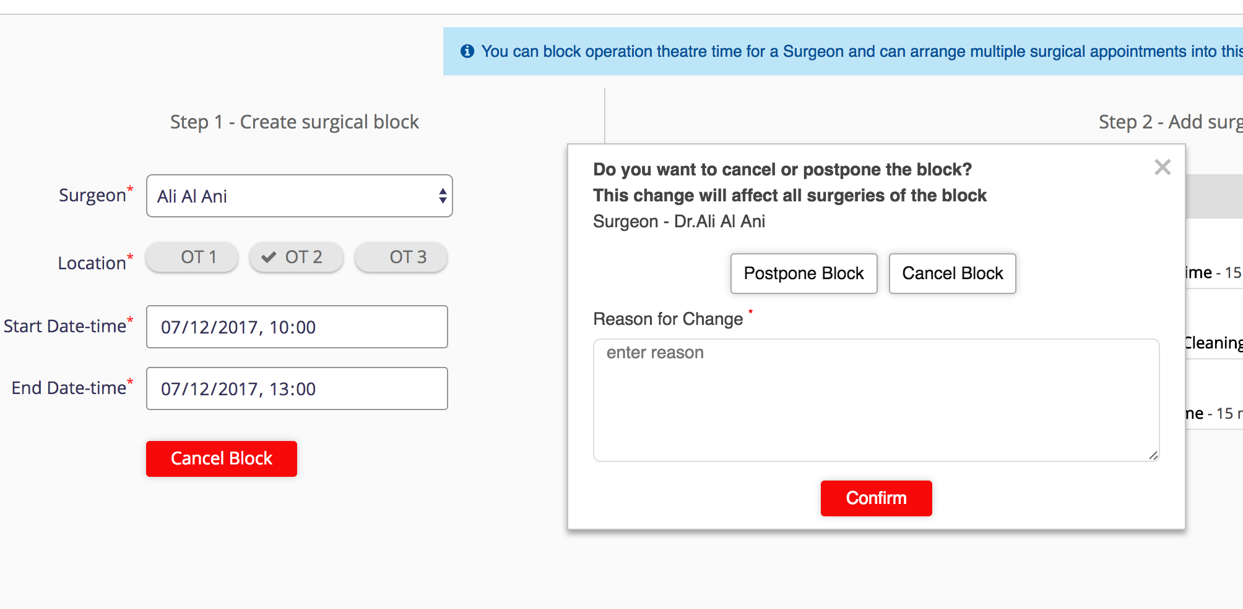

Actions that can be performed on blocks:

Block type | Edit | Postpone | Cancel
Surgical Block with completed surgeries | Yes | No | No
Surgical Block without completed surgeries | Yes | Yes | Yes

Edit, Cancel or Postpone Surgery
A user can perform the below actions on a surgery
- Edit Surgery:
  - A user can edit surgeries from calendar view and list view
  - A user can also edit surgeries from “Edit surgical block” view
  - A user needs to select a surgery and the edit button on the left bottom will enable
  - Upon clicking on edit, user will be taken to edit surgical block page where selected

**All the fields in the surgery are editable except the patient details, In edit mode the Patient name (ID) will become a hyperlink that will navigate the user to the patient summary dashboard**

- Cancel Surgery:
  - A user can cancel a surgery from calendar view and list view
  - A user can also cancel a surgery from “edit surgical block” view
  - A user needs to select a surgery in the calendar view and the cancel button on the left bottom will enable
  - When cancel is selected, there is a pop up that asks if a user wants to cancel the surgery or postpone it.
  - User has to click on cancel, select “Cancel Surgery” and enter a reason in order to cancel the surgery
  - If the surgery is “completed”, a user will not be able to cancel the surgery

- Postpone Block:
  - A user can postpone a surgery from calendar view
  - A user can also postpone a surgery from “edit surgical block” view
  - A user needs to select a surgery in the calendar view and the cancel button on the left bottom will enable
  - User has to click on cancel, select “Postpone surgery” and enter a reason in order to postpone the surgery
  - If a surgery is “completed”, a user will not be able to postpone the surgery
Note: In order to reschedule the postponed surgeries, a user will have to create a new surgery for the patient.

Actions that can be performed on a surgery:

Surgery Status | Edit | Postpone | Cancel
Scheduled | Yes | Yes | Yes
Completed | Yes | No | No
Postponed | No | No | No
Cancelled | No | No | No

OT Roles and Privileges:
The below are the OT privileges available in openMRS:

Privileges | Description
app:ot | Ability to view OT module
app:ot:write | Ability to view new surgical block and other buttons to edit on OT module
Manage OT Schedules | Ability to manage OT schedules
View OT Schedules | Ability to view OT schedules

Two roles have also been created in openMRS: OT : ReadOnly, OT : FullAccess

Feature | OT : ReadOnly | OT : FullAccess
To be scheduled queue | Cannot view | Can view
Scheduled queue | Can view | Can view
OT calendar | Can view | Can view
List view | Can view | Can view
Print list view | Can print | Can print
Add a new surgical block | Cannot add | Can add
Add surgeries | Cannot add | Can add
Edit | Cannot edit | Can edit
Add actual time | Cannot add | Can add
Cancel | Cannot cancel | Can cancel
Filter | Can filter | Can filter

Surgical Queues - “To be scheduled” & “scheduled”
Two Surgical Queues have been added:
- To be scheduled:
This queue shows a list of patients that have a surgeon pre-op assessment form or a surgeon follow up form filled with “Patient consent” as “yes” and who do not have an surgery scheduled post filling the form.
The queue also shows a list of postponed surgeries
Sorted on: date of form filled (earliest first)

- Scheduled:
This queue shows a list of patients that have “scheduled” appointments sorted on date of surgery (earliest first)

Detailed document on the queues can be found here.

Validations and constraints:
- If there is no form filled for a user and a surgery has been created and postponed. This surgery will not be shown on the “to be scheduled” queue
- Multiple postponed surgeries for a user will not be shown on “to be scheduled” queue
- Once the surgery is completed/postponed or cancelled the surgery is not shown in the “scheduled” queue.

Surgical Appointment Display Control in Patient Summary Dashboard
A custom display control has been set up for a user to view patient surgery details on the dashboard.

Mockup:
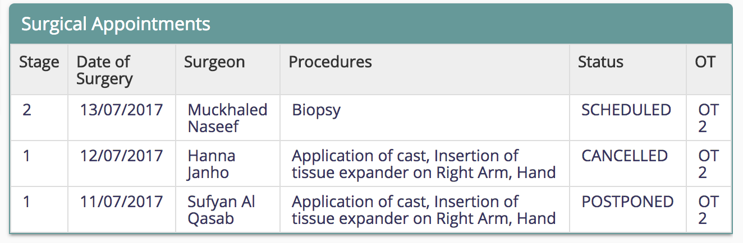

Field | Description
Stage | The stage entered in first stage/follow up at the time of the surgery
Date of Surgery | The date the surgery is scheduled to happen
Surgeon | The name of the surgeon whose block the patient has a surgery in
Procedures | Procedures entered during the addition of surgery
Status | Latest status of the surgery: Scheduled/Completed/Cancelled/Postponed
OT | The OT where the surgery was scheduled

High Level DB Schema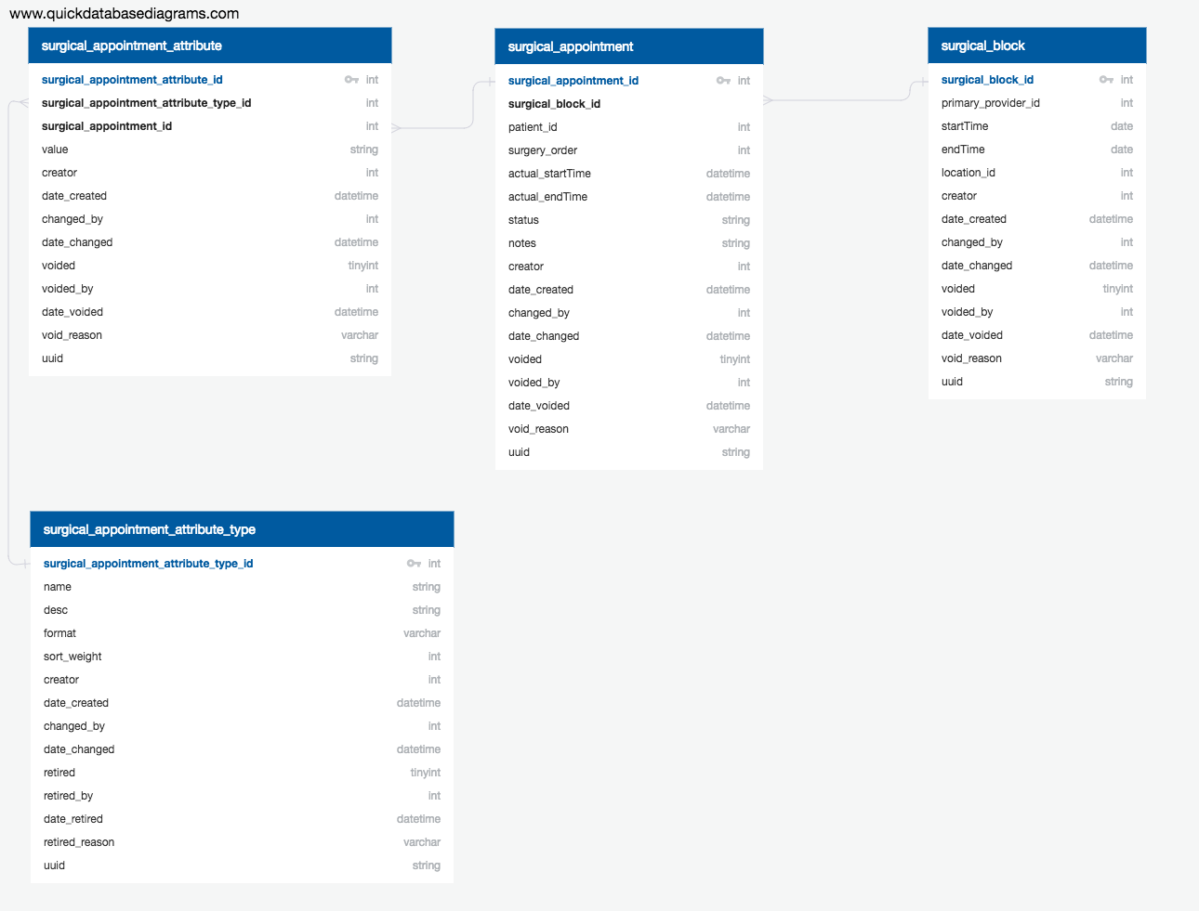

https://app.quickdatabasediagrams.com/#/schema/0i_hSbJDdkqwFFlIu8x9gg

Frequently asked questions

Q. What does it take to use the current OT module in the other Implementations ?
- Number of Operation theatres is configurable. All operation theatres are alphabetically displayed.
- OT’s are modeled as Locations with tags
- Calendar hours are configurable
- Works only for Block Scheduling
  - One Surgical appointment can be created in one block to use it as for classic scheduling
- Pre-Op and Post Operative information is recorded in the form of Observations and aid the users in creating OT Schedules. Works in any other hospital which has a similar need

Q. Can I add a Surgical appointment without creating block ?
- No. You have to create a Surgical block to create a surgical appointment

Q. What is the number of Surgical appointments in the Surgical block ?
- Surgical appointments can be as many as the Surgical block can accommodate

Q. Why am I not able to see Cancelled & Postponed appointments on the calendar view ?
- Calendar view does not show cancelled or postponed appointments. This is to indicate the user that there are some open slots & OT admin can accommodate new appointments. List view allows you to filter appointments by Cancelled & Postponed status.

Q. How do I mark a surgical appointment complete ?
- As Soon as you enter Actual time against a Surgical appointment, the appointment is treated as Complete.

Q.What if I entered “Actual Time” for a patient whose surgery is not yet done ?
- System allows you for correction of Actual Time, by clearing it. The default estimated time is automatically populated and the Surgical appointment status changes to Scheduled.

Q. What is Actual time used for ?
- Actual Time allows you to enter Actual Time taken for the surgery. You can update actual time multiple times.

Q. Surgery is scheduled from 09:00 AM to 11:00 AM and I have updated Actual time for surgery as 09:00 to 09:30. My Calendar still shows the Surgical appointment from 09:00 AM to 11:00 AM. Why ?
- Today, we allow user to record actual time. Actual time is not reflected on the calendar.
Q. My Planned procedures and estimated time section does not fill automatically on adding patient. Why?
- If a surgeon pre-op assessment form or a surgeon follow up form has not been filled with patient consent planned procedures and estimated time then these fields do not auto populate

Q. I have more than one postponed surgeries for a patient with different planned procedures but I don't see those surgeries in the ‘to be scheduled” queue. Why?
- It is assumed that only when a surgery is completed / cancelled another surgery is scheduled. Having said that, if there are multiple appointments, the assumption is that the latest appointment is only valid. Hence, we only see the latest surgery.

Q. I want to see all the postponed surgeries. How do i do that?
- You can do that from the list view by adding “postponed” as your filter. You can also add additional filters to it like patient id, surgeon and OT

Q. Can I add surgeries without filling any forms?
- Yes, you may add surgeries without filling any forms in observations, but if these surgeries are postponed, they will not appear in the “to be scheduled” queue.

