Data Model

Let us see the data model of the Bahmni, followed by the proposed model.

BAHMNI DATA MODEL

Bahmni Data Model is based on OpenMRS 1.11 A Concept is a data point pertaining to a Patient.

concept
Field Name | Data Type | Description
concept_id | integer(10) | Unique number identifying a pre-defined Concept in the Concept Dictionary
retired | bit | Signifies if a Concept is actively referred to in the system or not (Indicates whether or not this term is used)
short_name | varchar(255) | A generic (identifiable) name for the Concept
description | long varchar(65535) | Descriptive text explaining what the Concept refers to, i.e. drug, disease etc.
form_text | long varchar(65535) | User Interface description for components
datatype_id | concept_datatype.concept_datatype_id | Datatype ID associated with a Concept datatype indicating what type of term (ingredient, frequency, units etc.) the Concept refers to
class_id | concept_class.concept_class_id | Class or Type of Concept (Diagnosis, Drug Ingredient etc.)
is_set | bit | Identifies if the Concept value is set(defined)
creator | users.user_id | Specifies the Person ID of the Person who created or entered the Concept name and details in the system - Administrator
date_created | timestamp(19) | Specifies the Date on which this Concept was entered/stored in the system to be used by the Administrator
version | varchar(50) | Specifies the version of the defined Concept
changed_by | users.user_id | Specifies the Person ID of the Person who last edited the definition of the Concept - Administrator
date_changed | timestamp(19) | Specifies the Date on which the definition of the Concept was last edited
retired_by | users.user_id | Specifies the Person ID of the Person who removed this Concept from the list of active Concepts that could be referred to - Administrator
date_retired | timestamp(19) | Specifies the Date on which this drug was removed from the list of active referable Concepts
retire_reason | varchar(255) | Specifies the reason due to which this drug was removed from the list of active referable Concepts
uuid | char(38) | Auto-fill unique identifier identifying this record in the table

(Fig. 1.1 - Bahmni - Concept table)

drug
Field Name | Data Type | Description
drug_id | integer(10) | Unique number identifying a drug
concept_id | concept.concept_id | The Concept ID which defines the class or unique identity associated with this drug
name | varchar(255) | Brand name of the drug by which it is commonly referred to while being ordered
combination | bit | Specifies if the drug is composed of two or more active pharmaceutical ingredients
dosage_form | concept.concept_id | The form in which the drug is consumed (Powder, Tablet, Syrup, Injection, Smell etc.)
maximum_daily_dose | double(22) | Maximum dose of drug consumption that can be prescribed on a daily basis
minimum_daily_dose | double(22) | Minimum dose of drug consumption that can be prescribed on a daily basis
route | concept.concept_id | The route by which the Patient consumes the drug (Oral, Injection, Ointment etc.)
creator | users.user_id | Specifies the Person ID of the person who recorded this Concept drug in the system - Administrator
date_created | timestamp(19) | Specifies the Date on which the drug was recorded / defined in the system
retired | bit | Specifies if this Drug is allowed to be ordered through the system, i.e. if it is/is not active in circulation
retired_by | users.user_id | Specifies the Person ID of the person who removed this Drug Concept from the list of orderable drugs - Administrator
date_retired | timestamp(19) | Specifies the Date on which the drug Concept was removed from the list of orderable drugs
retire_reason | varchar(255) | Specifies the reason for removing this drug from the list of orderable drugs
uuid | char(38) | Auto-fill unique identifier identifying this record in the table
date_changed | timestamp(19) | Specifies the Date on which the set drug composition fields were edited or the record was removed from the ‘Active’ Concept Drug list
changed_by | users.user_id | Specifies the Person ID of the Person who last edited the default drug composition field values - Administrator
strength | varchar(255) | Specifies the strength of the formulary (e.g. 100 mg)

(Fig. 1.2 - Bahmni - Drug table)

Drug Ingredient table contains data about the ingredients which make up one drug.

drug_ingredient
Field Name | Data Type | Description
drug_id | drug.drug_id | Unique number identifying a drug
ingredient_id | concept.concept_id | Unique number identifying an ingredient which the drug is composed of
uuid | char(38) | Auto-fill unique identifier identifying the record in the table
strength | double(22) | Strength of the formulary (Value-Units, e.g. ‘5’ in 5 mg) of the ingredient in the drug
units | concept.concept_id | Unit corresponding to the strength of the formulary (mg, ml, etc.)

(Fig. 1.3 - Bahmni - Ingredients table)

The Drug Order table stores data about the elements associated with the drug order.

drug_order
Field Name | Data Type | Description
order_id | orders.order_id | Unique number identifying a Drug Order
drug_inventory_id | drug.drug_id | Unique identifier corresponding to the inventory which this drug is a part of
dose | double(22) | A number signifying the strength of the drug (e.g. ‘100’ in 100 ml)
as_needed | bit | Specifies the value set corresponding to a checkmark on the UI that Indicates that the drug only needs to be consumed 'as needed'
dosing_type | varchar(255) | Specifies the fields that are active on the UI form - Standard field values corresponding to standard composition parameters or Free text instructions typed by the Physician on orders
quantity | double(22) | Specifies the number signifying the quantity of a drug to be dispensed (e.g. 1, 2.5, 3…)
as_needed_conditions | varchar(255) | Specifies the conditions during which the Patient is allowed to consume this drug (Free Text)
num_refills | integer(10) | Specifies the number of times the order can be renewed or refilled for the drug to be dispatched/administered to the Patient
dosing_instructions | long varchar(65535) | Specifies free text instructions for the Patient for consuming the drug
duration | integer(10) | Specifies the Duration for which the drug needs to be dispensed to the patient (3, 5, 10 (days))
duration_units | concept.concept_id | Specifies the Units corresponding to duration for which the patient is given the drug (Days, Hours)
quantity_units | concept.concept_id | Specifies the Units corresponding to the quantity of medicines given to the patient  (e.g. 2 Units of 50 mg of Drug)
route | concept.concept_id | Specifies the route by which the patient is administered the drug (Oral, Injection, Ointment)
dose_units | concept.concept_id | Specifies the Units corresponding to the dose which signifies the strength of the drug (e.g. mg, ml, etc.)
frequency | order_frequency.order_frequency_id | Specifies the frequency at which the patient needs to consume the drug (e.g. 7 days/week, 2 times/day etc.)
brand_name | varchar(255) | Specifies the brand or generic name by which the drug is commonly identified
dispense_as_written | bit | Indicates if the drug is to be dispensed as explicitly specified in the instructions

(Fig. 1.4 - Bahmni - Drug Order table)
The Drug Reference Map table stores information with respect to inclusion or removal of the Drug Concept and the related terms or other vocabularies from the system.

drug_reference_map
Field Name | Data Type | Description
drug_reference_map_id | integer(10) | Unique number identifying the reference of the Drug mapped to other concepts (e.g. can get the list of retired drugs this drug is associated with)
drug_id | drug.drug_id | Unique number identifying the Drug
term_id | concept_reference_term.concept_reference_term_id | Unique identifier for the Term to which the Drug Concept is mapped to
concept_map_type | concept_map_type.concept_map_type_id | Specifies the unique identifier for the type of mapping between the drug and the other concept
creator | users.user_id | Specifies the Person ID of the Person who created this definition - Administrator
date_created | timestamp(19) | Specifies the Date on which the reference definition was recorded in the system
retired | bit | Bit signifying if this reference is active or not in the system
retired_by | users.user_id | Specifies the Person ID of the Person who removed this reference from the list of active references - Administrator
date_retired | timestamp(19) | Specifies the Date on which the reference was removed from the list of active references
retire_reason | varchar(255) | Specifies the Reason why this reference was removed from the list of active references
changed_by | users.user_id | Specifies the Person ID of the Person who last edited the definition or a field corresponding to this reference - Administrator
date_changed | timestamp(19) | Specifies the Date on which the definition or a value corresponding to this reference was last edited
uuid | char(38) | Auto-fill unique identifier identifying this record in the table

(Fig. 1.5 - Bahmni - Drug Reference table)

DATA MODEL

In this section, we will see the design and analysis of the proposed module’s data model.
Refer Data Dictionary on the following pages for the descriptions.

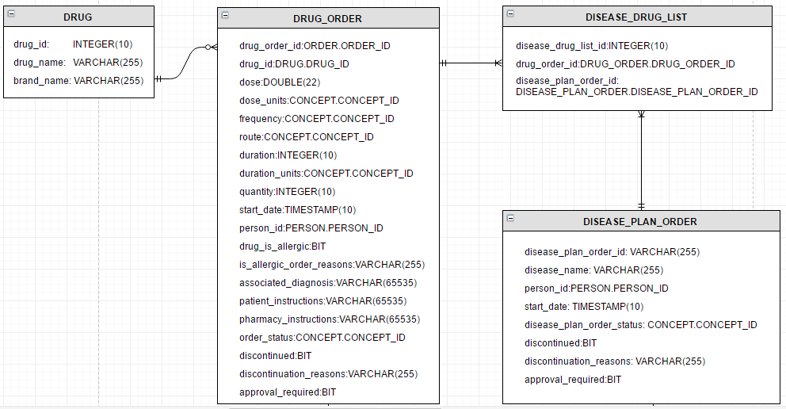

The Drug Order table represents all the parameters associated with an individual drug order. With reference to the wireframes for Individual Drug Orders, each field pertaining to drug composition or drug consumption details will be unique to that order and must be stored with suitable references to the Drug Order ID. It is also required to note the indication of the drug being or not being allergic to the patient and the reasons to order an allergic drug. It will also include the fields to store the Order status (fulfilled/held for approval/discontinued etc.)

Drug Order
Field Name | Data Type | Description
drug_order_id | ORDER.ORDER_ID | Unique number identifying the order
drug_id | DRUG.DRUG_ID | Commonly recognized Drug Name
dose | DOUBLE(22) | Value indicating the strength of the Drug (e.g. 100 in 100 mg of drug name)
dose_units | CONCEPT.CONCEPT_ID | Specifies the unit of measurement (mg, ml etc.)
frequency | CONCEPT.CONCEPT_ID | Specifies the Frequency of consumption (e.g. 7 days/week, 2 times/day etc.)
route | CONCEPT.CONCEPT_ID | Specifies the Route of consumption (Oral, Injection)
duration | INTEGER(10) | Specifies the Duration of consumption (6 in 6 days)
duration_units | CONCEPT.CONCEPT_ID | Specifies the Duration Units (days, hours etc.)
quantity | INTEGER(10) | Specifies the Quantity (a number) of consumption
start_date | TIMESTAMP(10) | Specifies the Start Date from which the Patient has to consume this drug
person_id | PERSON.PERSON_ID | Specifies the Person ID of the Person for whom drug is being ordered – Patient ID
drug_is_allergic | BIT | Indicates if the drug is allergic or not for the patient
is_allergic_order_reasons | VARCHAR(255) | Specifies the reason to order a drug despite knowing that the Patient is allergic to it
associated_diagnosis | VARCHAR(65535) | Specifies the description of the diagnosis on the basis of which this drug is prescribed
patient_instructions | VARCHAR(65535) | Instructions given by the Physician to the Patient
pharmacy_instructions | VARCHAR(65535) | Instructions given by the Physician to the Pharmacist
order_status | CONCEPT.CONCEPT_ID | Indicates the status of the order - fulfilled, cancelled, held for approval etc.
discontinued | BIT | Indicates if this order has been discontinued
discontinuation_reasons | VARCHAR(255) | Specifies the reasons to discontinue an order
approval_required | BIT | Indicates whether senior Physician’s approval is required to prescribe this drug to the Patient

(Fig 3.1 – Drug Order Table)
The DRUG table stores drug specific information including the name of the drug as well as the manufacturer’s brand name to uniquely identify the drug.

Drug
Field Name | Data Type | Description
drug_id | INTEGER(10) | Unique number identifying the Drug
drug_name | VARCHAR(255) | Commonly recognized name of the Drug
brand_name | VARCHAR(255) | Name of the manufacturing brand of the Drug

(Fig 3.2 – Drug Table)

The DISEASE PLAN ORDER table represents the pre-defined medication plan Orders associated with a patient. Each Order corresponds to a disease. In the case of a pre-defined medication plan, the order for a plan will have a specific Start Date for all the drugs that are being ordered as a set to treat this disease.

Given that the Physician may choose to discontinue a plan, relevant fields are provided.

Disease Plan Order
Field Name | Data Type | Description
disease_plan_order_id | ORDER.ORDER_ID | Unique number identifying the Disease Plan Order
disease_name | VARCHAR(255) | Commonly identified name of the Disease
person_id | PERSON.PERSON_ID | Specifies the Person ID of the Person for whom the drug is being ordered - Patient
start_date | TIMESTAMP(10) | Specifies the Start Date of medication
disease_plan_order_status | CONCEPT.CONCEPT_ID | Indicates the status of the order – whether fulfilled, discontinued, cancelled etc.
discontinued | BIT | Specifies whether this plan has been discontinued or is still active / being fulfilled
discontinuation_reasons | VARCHAR(255) | Specifies the reasons to discontinue an active plan
approval_required | BIT | Indicates whether senior physician’s approval is required for the drug to be prescribed to the Patient (for the Order to be placed)

(Fig 3.3 – Disease Plan Order Table)

Each order (Disease plan) has several individual drug Orders associated with it and that is represented in the Disease Drug List table.

The DISEASE DRUG LIST table provides a mapping of a disease with the drugs which are defined to be a part of the disease treatment medication plan. A disease may have one or more drugs prescribed as a part of the treatment plan, and every individual drug being prescribed as a part of the plan contains its own Drug Order table entry.

Disease Drug List
Field Name | Data Type | Description
disease_drug_list_id | INTEGER(10) | Unique number identifying the Disease Drug List record ID
drug_order_id | DRUG_ORDER.DRUG_ORDER_ID | Unique Drug Order ID of the drug which is a part of the list of drugs being ordered in the disease treatment plan
disease_plan_order_id | DISEASE_PLAN_ORDER.DISEASE_PLAN_ORDER_ID | Unique number identifying the disease for which the given drug is pre-defined to be ordered as a treatment plan

(Fig 3.4 – Disease Drug Table)

The PHARMA ORDER table provides a record of components or fields filled in by the Pharmacist while taking an action on an Order – Dispatch, Put it on Hold, Cancel. These are additional fields associated with each approved or placed Order.

The fields pertaining to comments and messages are optional and will be filled by the Pharmacist. This table has a one-to-one relationship or corresponding record with the Drug Order table but for simplicity, we will store them separate.

We have 2 separate comment fields since the Pharmacist may choose to make a note for the record and may or may not have another message for the ordering physician.

Pharma Order
Field Name | Data Type | Description
pharma_order_id | INTEGER(10) | Unique Pharma Order ID
drug_order_id | ORDER.ORDER_ID | Reference to the corresponding Drug Order ID
pharma_comments | VARCHAR(65535) | Pharmacist's comments upon taking an action
forward_comments | BIT | Bit indicating if the Pharmacist’s comments is to be forwarded to the ordering physician
send_new_message | BIT | Bit indicating if the Pharmacist wants to send a separate message to the ordering physician
new_message | VARCHAR(65535) | Pharmacist's message to the Physician

(Fig 3.5 – Pharma Order Table)

