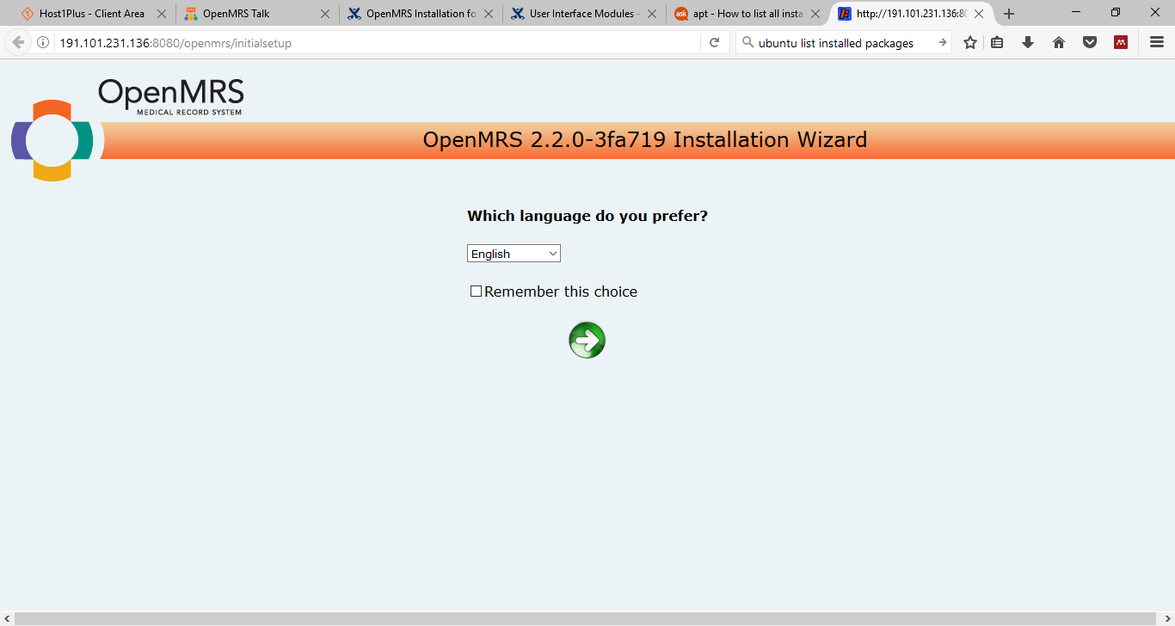

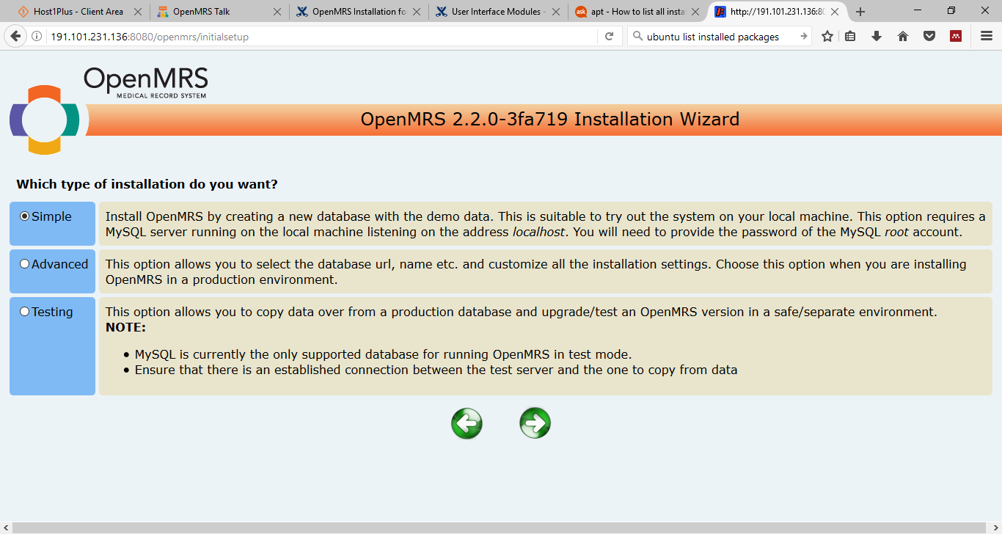

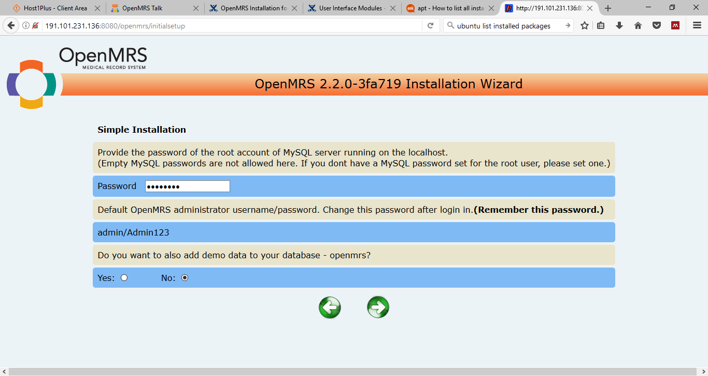
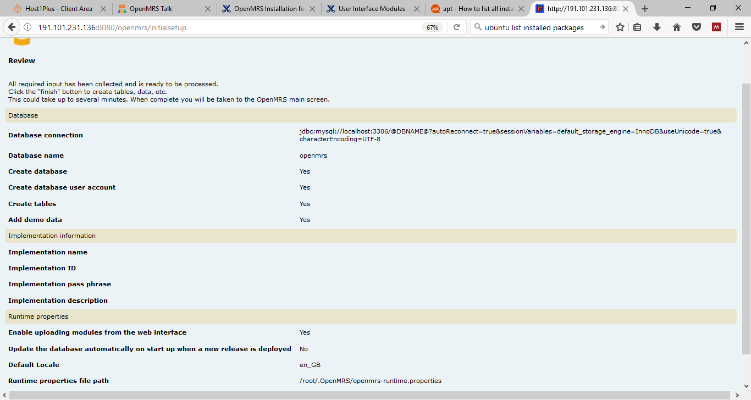

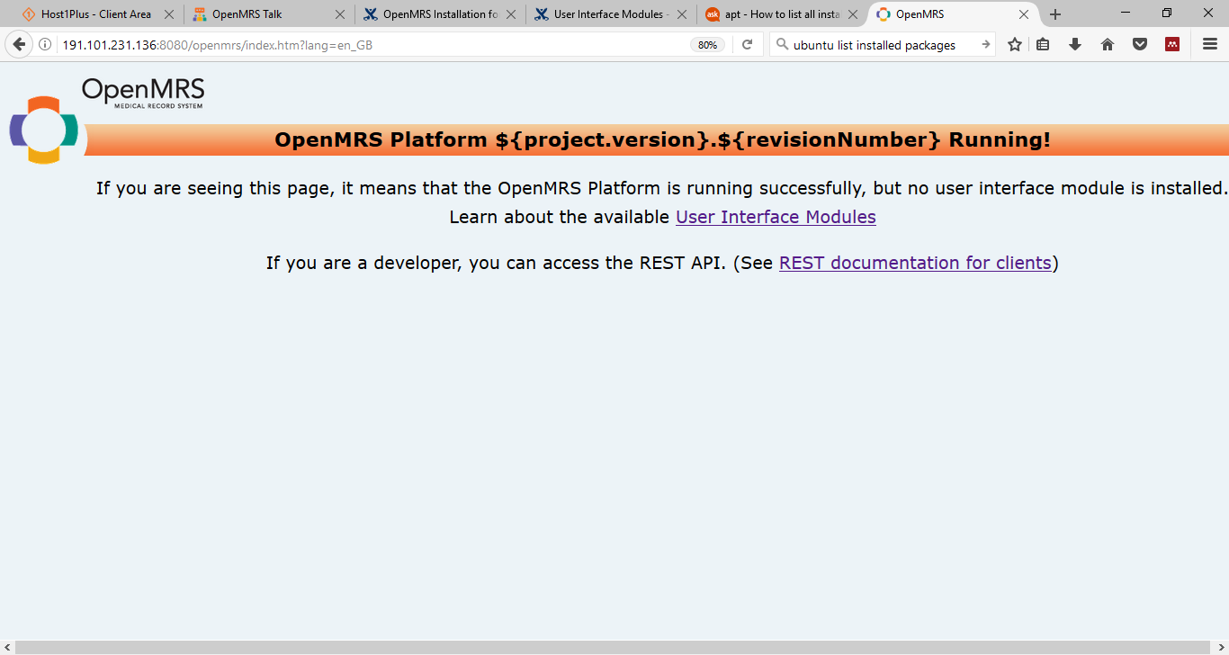

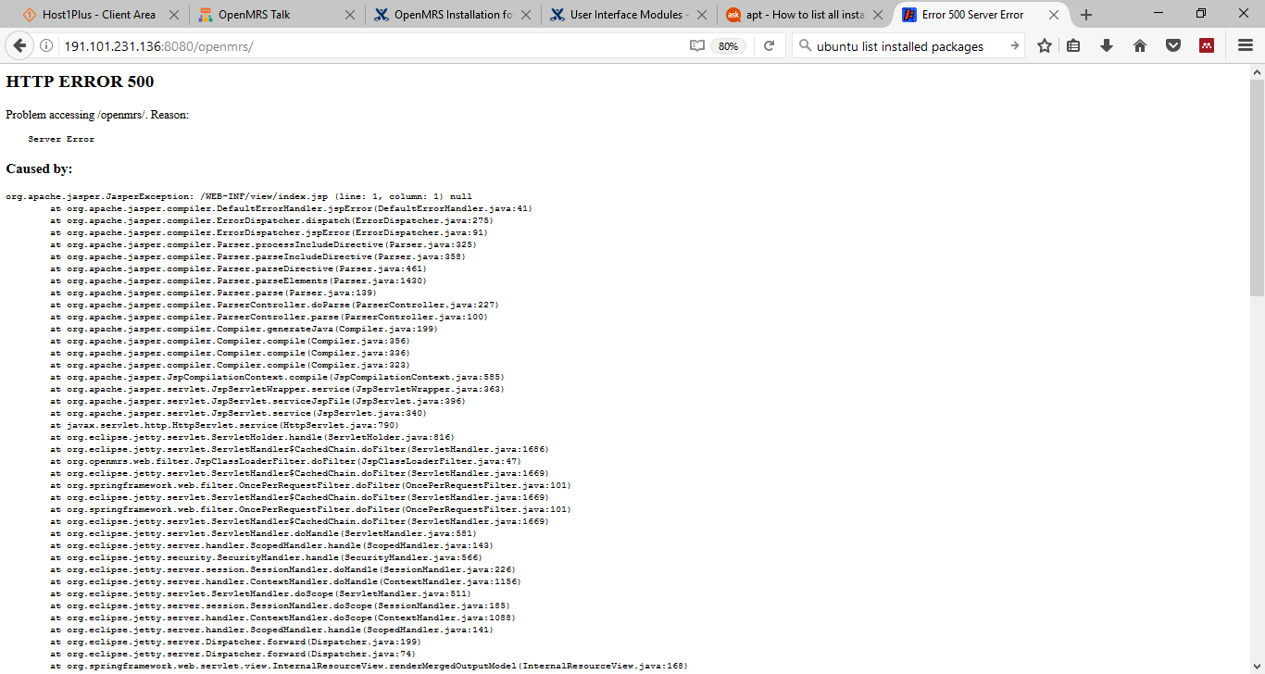

Full error copied from webpage below:

HTTP ERROR 500
Problem accessing /openmrs/. Reason:
Server Error

Caused by:
org.apache.jasper.JasperException: /WEB-INF/view/index.jsp (line: 1, column: 1) null
at org.apache.jasper.compiler.DefaultErrorHandler.jspError(DefaultErrorHandler.java:41)
at org.apache.jasper.compiler.ErrorDispatcher.dispatch(ErrorDispatcher.java:275)
at org.apache.jasper.compiler.ErrorDispatcher.jspError(ErrorDispatcher.java:91)
at org.apache.jasper.compiler.Parser.processIncludeDirective(Parser.java:325)
at org.apache.jasper.compiler.Parser.parseIncludeDirective(Parser.java:358)
at org.apache.jasper.compiler.Parser.parseDirective(Parser.java:461)
at org.apache.jasper.compiler.Parser.parseElements(Parser.java:1430)
at org.apache.jasper.compiler.Parser.parse(Parser.java:139)
at org.apache.jasper.compiler.ParserController.doParse(ParserController.java:227)
at org.apache.jasper.compiler.ParserController.parse(ParserController.java:100)
at org.apache.jasper.compiler.Compiler.generateJava(Compiler.java:199)
at org.apache.jasper.compiler.Compiler.compile(Compiler.java:356)
at org.apache.jasper.compiler.Compiler.compile(Compiler.java:336)
at org.apache.jasper.compiler.Compiler.compile(Compiler.java:323)
at org.apache.jasper.JspCompilationContext.compile(JspCompilationContext.java:585)
at org.apache.jasper.servlet.JspServletWrapper.service(JspServletWrapper.java:363)
at org.apache.jasper.servlet.JspServlet.serviceJspFile(JspServlet.java:396)
at org.apache.jasper.servlet.JspServlet.service(JspServlet.java:340)
at javax.servlet.http.HttpServlet.service(HttpServlet.java:790)
at org.eclipse.jetty.servlet.ServletHolder.handle(ServletHolder.java:816)
at org.eclipse.jetty.servlet.ServletHandler$CachedChain.doFilter(ServletHandler.java:1686)
at org.openmrs.web.filter.JspClassLoaderFilter.doFilter(JspClassLoaderFilter.java:47)
at org.eclipse.jetty.servlet.ServletHandler$CachedChain.doFilter(ServletHandler.java:1669)
at org.springframework.web.filter.OncePerRequestFilter.doFilter(OncePerRequestFilter.java:101)
at org.eclipse.jetty.servlet.ServletHandler$CachedChain.doFilter(ServletHandler.java:1669)
at org.springframework.web.filter.OncePerRequestFilter.doFilter(OncePerRequestFilter.java:101)
at org.eclipse.jetty.servlet.ServletHandler$CachedChain.doFilter(ServletHandler.java:1669)
at org.eclipse.jetty.servlet.ServletHandler.doHandle(ServletHandler.java:581)
at org.eclipse.jetty.server.handler.ScopedHandler.handle(ScopedHandler.java:143)
at org.eclipse.jetty.security.SecurityHandler.handle(SecurityHandler.java:566)
at org.eclipse.jetty.server.session.SessionHandler.doHandle(SessionHandler.java:226)
at org.eclipse.jetty.server.handler.ContextHandler.doHandle(ContextHandler.java:1156)
at org.eclipse.jetty.servlet.ServletHandler.doScope(ServletHandler.java:511)
at org.eclipse.jetty.server.session.SessionHandler.doScope(SessionHandler.java:185)
at org.eclipse.jetty.server.handler.ContextHandler.doScope(ContextHandler.java:1088)
at org.eclipse.jetty.server.handler.ScopedHandler.handle(ScopedHandler.java:141)
at org.eclipse.jetty.server.Dispatcher.forward(Dispatcher.java:199)
at org.eclipse.jetty.server.Dispatcher.forward(Dispatcher.java:74)
at org.springframework.web.servlet.view.InternalResourceView.renderMergedOutputModel(InternalResourceView.java:168)
at org.springframework.web.servlet.view.AbstractView.render(AbstractView.java:303)
at org.springframework.web.servlet.DispatcherServlet.render(DispatcherServlet.java:1228)
at org.springframework.web.servlet.DispatcherServlet.processDispatchResult(DispatcherServlet.java:1011)
at org.springframework.web.servlet.DispatcherServlet.doDispatch(DispatcherServlet.java:955)
at org.springframework.web.servlet.DispatcherServlet.doService(DispatcherServlet.java:877)
at org.springframework.web.servlet.FrameworkServlet.processRequest(FrameworkServlet.java:966)
at org.springframework.web.servlet.FrameworkServlet.doGet(FrameworkServlet.java:857)
at javax.servlet.http.HttpServlet.service(HttpServlet.java:687)
at org.springframework.web.servlet.FrameworkServlet.service(FrameworkServlet.java:842)
at javax.servlet.http.HttpServlet.service(HttpServlet.java:790)
at org.eclipse.jetty.servlet.ServletHolder.handle(ServletHolder.java:816)
at org.eclipse.jetty.servlet.ServletHandler$CachedChain.doFilter(ServletHandler.java:1686)
at org.springframework.web.filter.OncePerRequestFilter.doFilter(OncePerRequestFilter.java:101)
at org.eclipse.jetty.servlet.ServletHandler$CachedChain.doFilter(ServletHandler.java:1669)
at org.springframework.web.filter.OncePerRequestFilter.doFilter(OncePerRequestFilter.java:101)
at org.eclipse.jetty.servlet.ServletHandler$CachedChain.doFilter(ServletHandler.java:1669)
at org.eclipse.jetty.servlet.ServletHandler.doHandle(ServletHandler.java:581)
at org.eclipse.jetty.server.handler.ScopedHandler.handle(ScopedHandler.java:143)
at org.eclipse.jetty.security.SecurityHandler.handle(SecurityHandler.java:566)
at org.eclipse.jetty.server.session.SessionHandler.doHandle(SessionHandler.java:226)
at org.eclipse.jetty.server.handler.ContextHandler.doHandle(ContextHandler.java:1156)
at org.eclipse.jetty.servlet.ServletHandler.doScope(ServletHandler.java:511)
at org.eclipse.jetty.server.session.SessionHandler.doScope(SessionHandler.java:185)
at org.eclipse.jetty.server.handler.ContextHandler.doScope(ContextHandler.java:1088)
at org.eclipse.jetty.server.handler.ScopedHandler.handle(ScopedHandler.java:141)
at org.eclipse.jetty.server.Dispatcher.forward(Dispatcher.java:199)
at org.eclipse.jetty.server.Dispatcher.forward(Dispatcher.java:74)
at org.eclipse.jetty.servlet.DefaultServlet.doGet(DefaultServlet.java:587)
at javax.servlet.http.HttpServlet.service(HttpServlet.java:687)
at javax.servlet.http.HttpServlet.service(HttpServlet.java:790)
at org.eclipse.jetty.servlet.ServletHolder.handle(ServletHolder.java:816)
at org.eclipse.jetty.servlet.ServletHandler$CachedChain.doFilter(ServletHandler.java:1686)
at org.openmrs.module.web.filter.ForcePasswordChangeFilter.doFilter(ForcePasswordChangeFilter.java:60)
at org.eclipse.jetty.servlet.ServletHandler$CachedChain.doFilter(ServletHandler.java:1669)
at org.openmrs.module.web.filter.ModuleFilterChain.doFilter(ModuleFilterChain.java:73)
at org.openmrs.module.web.filter.ModuleFilter.doFilter(ModuleFilter.java:57)
at org.eclipse.jetty.servlet.ServletHandler$CachedChain.doFilter(ServletHandler.java:1669)
at org.openmrs.web.filter.OpenmrsFilter.doFilterInternal(OpenmrsFilter.java:109)
at org.springframework.web.filter.OncePerRequestFilter.doFilter(OncePerRequestFilter.java:107)
at org.eclipse.jetty.servlet.ServletHandler$CachedChain.doFilter(ServletHandler.java:1669)
at org.springframework.orm.hibernate4.support.OpenSessionInViewFilter.doFilterInternal(OpenSessionInViewFilter.java:150)
at org.springframework.web.filter.OncePerRequestFilter.doFilter(OncePerRequestFilter.java:107)
at org.eclipse.jetty.servlet.ServletHandler$CachedChain.doFilter(ServletHandler.java:1669)
at org.openmrs.web.filter.StartupFilter.doFilter(StartupFilter.java:106)
at org.eclipse.jetty.servlet.ServletHandler$CachedChain.doFilter(ServletHandler.java:1669)
at org.openmrs.web.filter.StartupFilter.doFilter(StartupFilter.java:106)
at org.eclipse.jetty.servlet.ServletHandler$CachedChain.doFilter(ServletHandler.java:1669)
at org.openmrs.web.filter.StartupFilter.doFilter(StartupFilter.java:106)
at org.eclipse.jetty.servlet.ServletHandler$CachedChain.doFilter(ServletHandler.java:1669)
at org.springframework.web.filter.CharacterEncodingFilter.doFilterInternal(CharacterEncodingFilter.java:88)
at org.springframework.web.filter.OncePerRequestFilter.doFilter(OncePerRequestFilter.java:107)
at org.eclipse.jetty.servlet.ServletHandler$CachedChain.doFilter(ServletHandler.java:1669)
at org.eclipse.jetty.servlet.ServletHandler.doHandle(ServletHandler.java:581)
at org.eclipse.jetty.server.handler.ScopedHandler.handle(ScopedHandler.java:143)
at org.eclipse.jetty.security.SecurityHandler.handle(SecurityHandler.java:548)
at org.eclipse.jetty.server.session.SessionHandler.doHandle(SessionHandler.java:226)
at org.eclipse.jetty.server.handler.ContextHandler.doHandle(ContextHandler.java:1156)
at org.eclipse.jetty.servlet.ServletHandler.doScope(ServletHandler.java:511)
at org.eclipse.jetty.server.session.SessionHandler.doScope(SessionHandler.java:185)
at org.eclipse.jetty.server.handler.ContextHandler.doScope(ContextHandler.java:1088)
at org.eclipse.jetty.server.handler.ScopedHandler.handle(ScopedHandler.java:141)
at org.eclipse.jetty.server.handler.ContextHandlerCollection.handle(ContextHandlerCollection.java:213)
at org.eclipse.jetty.server.handler.HandlerCollection.handle(HandlerCollection.java:109)
at org.eclipse.jetty.server.handler.HandlerWrapper.handle(HandlerWrapper.java:119)
at org.eclipse.jetty.server.Server.handle(Server.java:517)
at org.eclipse.jetty.server.HttpChannel.handle(HttpChannel.java:306)
at org.eclipse.jetty.server.HttpConnection.onFillable(HttpConnection.java:242)
at org.eclipse.jetty.io.AbstractConnection$ReadCallback.succeeded(AbstractConnection.java:245)
at org.eclipse.jetty.io.FillInterest.fillable(FillInterest.java:95)
at org.eclipse.jetty.io.SelectChannelEndPoint$2.run(SelectChannelEndPoint.java:75)
at org.eclipse.jetty.util.thread.strategy.ExecuteProduceConsume.produceAndRun(ExecuteProduceConsume.java:213)
at org.eclipse.jetty.util.thread.strategy.ExecuteProduceConsume.run(ExecuteProduceConsume.java:147)
at org.eclipse.jetty.util.thread.QueuedThreadPool.runJob(QueuedThreadPool.java:654)
at org.eclipse.jetty.util.thread.QueuedThreadPool$3.run(QueuedThreadPool.java:572)
at java.lang.Thread.run(Thread.java:748)

Powered by Jetty:// 9.3.3.v20150827

Rebooted Server
