GSOC 2017
  - proposal -Data Integrity Module 4.x Improvement Project
Ridmal Liyanagamage | 2017/4/3
Table of Contents
Introduction 2
Project Objectives And Prposed Solutions. 2
Deliverables for objective 1 3
Deliverables for Objective 2 3
Deliverables for Objective 3 4
Deliverables for Objective 4 5
Deliverables for Objective 5 6
TimeLine 6
About me 8

Introduction
OpenMRS is a software and community which serves as an electronic medical record systems(EMR). OpenMRS is a java-based, web-based platform which integrated with many modules. Data integrity module is one of that module which provide facilities to create, manage and review data quality audits [2].
Basically integrity check is done base on this rules. https://wiki.openmrs.org/display/docs/Sample+Integrity+Checks
(Since full description about OpenMRS and data-integrity module are including in OpenMRS wiki this proposal not having much information about OpenMRS and OpenMRS data-integrity module.)

Project Objectives And Prposed Solutions.
In this GSOC project open MRS data integrity module need following enhancements and improvements.
- Improved filtering and display of rule violations on the current result page
In current data integrity module provide result set base on the integrity check (base on the rule). And that result set having all the results which match to the integrity check.
https://wiki.openmrs.org/display/docs/Data+Integrity+Module?preview=/3346520/35750071/view-results.png
This project goal is for achieve data filtering for result dataset base on the patient, program or rule. For example, if we run unused locations integrity check the result will be filter base on the rule. But we can filter result further using patient id or program id. (So increasing the data categories in the result set will help that filtering process.)
And in this part I am willing to add result count for particular integrity check and display in the UI. When user get action to each result again check the modified data is correct (follows the rules) and change the count of result set. It will help to avoid processing data integrity checks again and again to find the wrong data.

Deliverables for objective 1
- Add filtering option for result set. (Base on the patient, program id, etc.).
- Add result-set count on icon which will display the total count of result set.
(That count will be reducing after user get actions for that results)

- A widget to display violations on a program (soon to have a page) and the patient dashboard
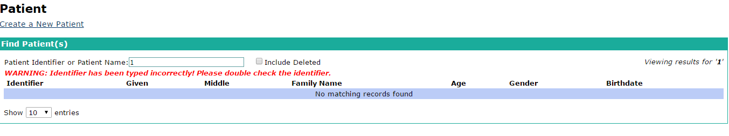
In current integrity model user interfaces and the patient/program dashboard are maintaining separately. So user need to choose integrity module options separately using the administration panel. But in my opinion this project goal tries to map data integrity module and the patient/program dashboard. So for that it requires a widget which display in patient/program dashboard with purpose of displaying violations of patients and program data.
So in the patient/program dashboard it will be having a widget for check violations according to the patient_ id which user enter. So It will be directly find the violations with regards to the patient id form the data_ integrity_ result table. (for that we need to get result sets for every rule when the server starts.) Also that widget helps to map data-integrity module options (UI) and patient/program dashboard. Further development - in every patient Id search process it will automatically search the violations and display on the widget.
This will pop up the violated rules according to the patient id (if exists in the database.)
Check violations

Deliverables for Objective 2
- Add mapper between OpenMRS patient/program dashboard and the data integrity module.
- Develop widget in OpenMRS patient/program dashboard which can check violations form that dashboard. (base on the patient id or program id).
- Future Development – Add icon for show violation amount for each patient in patient details table.

- Addition of an SQL interface to run queries for testing violations.
According to this issue user can add any role to the system and find result datasets base on that roles. So separate user interface need to be developed for this process.
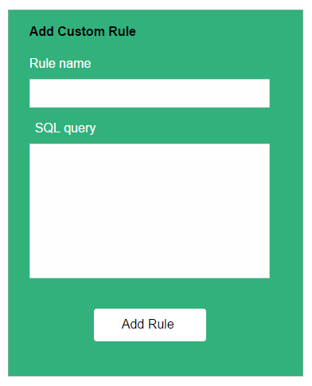

(Sample UI for add custom roles in data-integrity module)
So as mentioned in the DINT-70 JIRA issue SQL statement need to be checking before add to the system. (So for that we can have separate rule to check validity of that custom rule). So after successfully adding roles to the system it will be joining with the default rule set.

Deliverables for Objective 3
- Develop a UI for adding custom rules.
- Check validation of SQL queries which user added to the system.

- Making the module ready for Platform 2.0.x
According to https://wiki.openmrs.org/display/docs/Supporting+Platform+2.0+and+below
this information it consists two methods which can upgrade data-integrity module which compatible with platform 2.0.x.
- Method that used in the X forms module.
https://github.com/openmrs/openmrs-module-xforms/commit/5d79f327d27777a40ec755a90433e4dc69067e4a
- Recommended Approach (Dbsession approach)
This is the best way for ready data-integrity module for platform 2.0.x and I am willing to use this approach in this enhancement.
So main steps need to done to fulfill this enhancement is describing in following link. https://wiki.openmrs.org/display/docs/Supporting+Platform+2.0+and+below

Deliverables for Objective 4
- Introduce openMRS Hibernate Compatibility to data-integrity module.
- Refactoring data integrity module code (Apply changes that require for upgrading module. ex – change SessionFactory to DbSessionFactory).

- Improving the flow to run a single rule from the list of rules or even for a single patient
In present data integrity module only having an option to get result set based on the rule. But this enhancement highlights that user can apply integrity check (list of integrity check) for every patient. So it helps to check violations of patients separately. So in the above I mentioned that we can use widget for check validations in patient dashboard. But this option can be implemented inside the data integrity module and patient dashboard.
So user need to first get the patient details using patient id then user can apply set of rules to that patient and check violations.
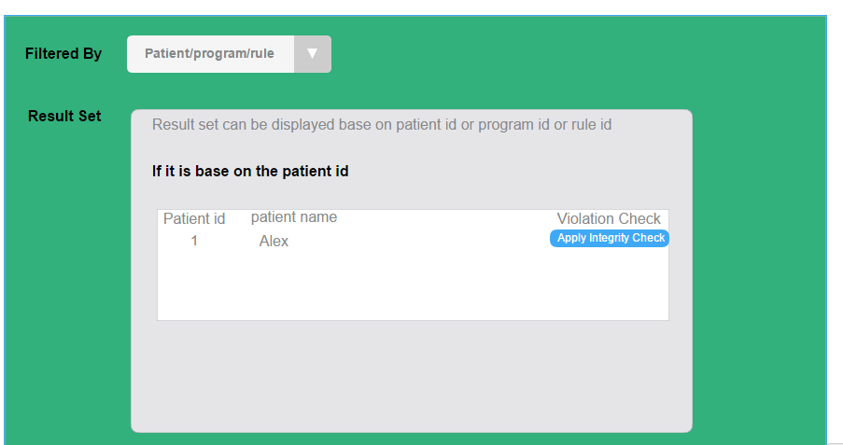
(Apply data integrity for each patient in data integrity module).

Deliverables for Objective 5
- Add option to get result set base on the patient and apply set of rules to check violations of that dataset.
- Future Development – Patient data can be get base on the different parameters (admit date, location,) and apply rules for that dataset.

TimeLine

Duration | Description | Mile Stone
Before May 4 | Before Announcement of Candidates | Get familiar with the data integrity module and tried to resolve issues in the data integrity module .( contribute to the existing data integrity module).
May 5– May 15 | Before Official Coding Period Starts | Understand the code base and database properly.
May 16- May 29 |  | Gather requirements for further enhancements mentioned in this project.
May 30 - June 5 | Official Coding Period Starts | Start Coding for new features.  Improved filtering and display of rule violations on the current result page.  ( Start working with this project)
June 6 - June 12 |  | Start working on next enhancement.  Addition of an SQL interface to run queries for testing violations.
June 13 - June 19 | Preparing for phase 1 evaluation. | Complete the implementations in first two parts and apply the testing to that enhancements.
June 20 - June 26 |  | Prepare documentation for completed to features and further testing on that two modules.(submission that two modules to the mentors for evaluation)
June 27- July 4 | After phase 1 evaluation | Start working on A widget to display violations on a program (soon to have a page) and the patient dashboard enhancement. (gather more requirement and start coding). Crate a UI widget that can display in the patient or program dashboard.
July 5- July 11 |  | Adding mapping layer between OpenMRS core and the data integrity module which will help to display violations in dashboards.
July 12- July 17 | Preparing for phase 2 evaluation | Complete that development of above module and apply testing for that.
July 17- July 24 |  | Prepare Documents for this module and submit to the mentors for evaluation and get feedback ( further development in that module ) .And start working on Making the module ready for Platform 2.0.x enhancement.
July 25- July 31 | Before  Final stage | Complete the enhancement of Making the module ready for Platform 2.0.x.
Aug 1 - Aug 7 |  | Start working on fifth enhancement (Improving the flow to run a single rule from the list of rules or even for a single patient). And complete that module.
Aug 8 -Aug 14 | Final Stage | Apply testing for both two modules and prepare documentations for that modules.
Aug 15 -Aug 21 |  | Prepare final documentation which included every information about new enhancements. Create complete user guide for that enhancement.( It can be done for the existing features too).And submit complete project to the mentors for evaluation.
(A buffer of one week has been kept for unpredictable delay.)

About me
My name is Ridmal Madushanka Liyanagamage. I am a 3rd year undergraduate of faculty of Information Technology in University of Moratuwa, Sri Lanka am self-motivated and I have a passion in coding and contributing open source projects. In my university career I have learned a lot of new things and important aspects which help for software development. (ex: database management (SQL and MYSQL), Coding languages (JAVA, JAVASCRIPT, NODE, PHP…), operating systems etc.). And most importantly I love to do social works and always tries to help others. So personally I think that OpenMRS is a platform which helps to the community. (mostly in developing countries). So I am willing to contribute to open MRs as my best.
Email Address – ridmal19@gmail.com
LinkedIn - linkedin.com/in/ ridmal-madushanka/
OpenMRS username – Ridmal ( ridmal19@gmail.com)
Github username – Ridmal madusanka.

