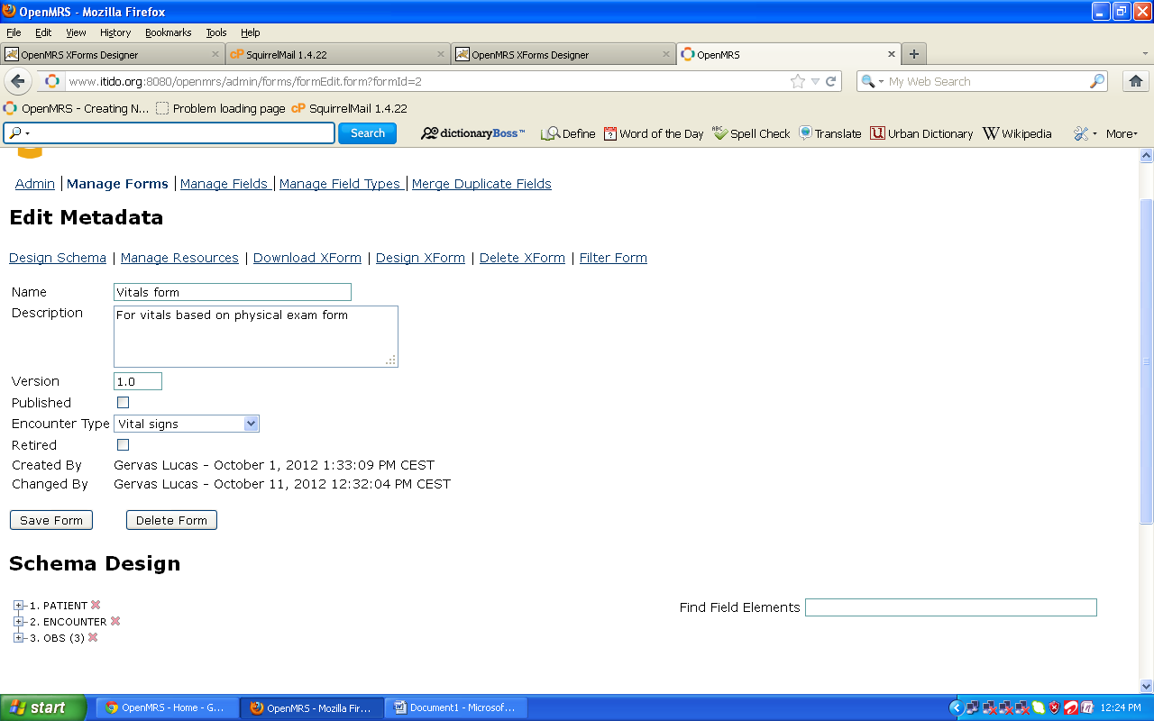
Open a form in a manage form, click on that form, expand obs Enter the id or concept name and see you concept showing up , click it to include it in the form schema.
Next step is to make sure the added field in the schema are in correct category drag and drop it under the obs category; you can expand all other category to explore them.
One more step now go back to the form designer interface and form or page on the form as select refresh as shown below
Step 2:
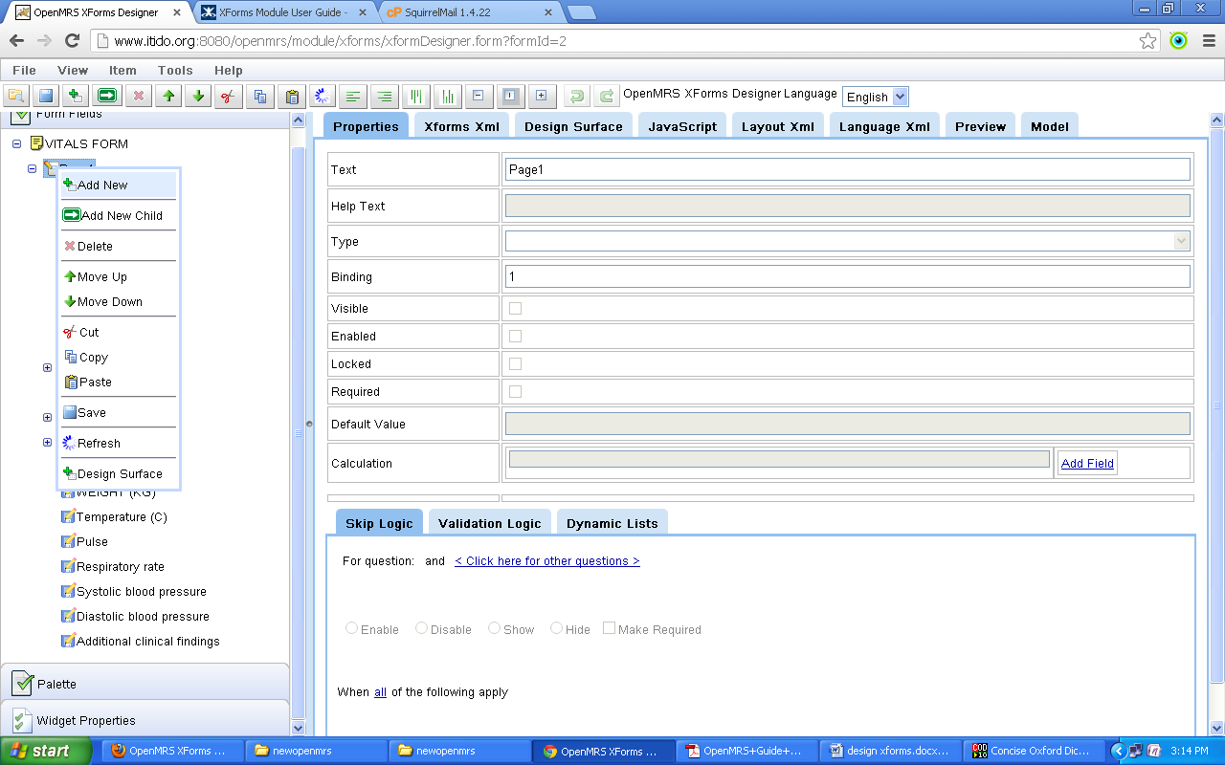
Select the design surface and refresh too and see now you new field included. Eplore more and more the design surface.

